OLHA BUDNYK *, PIOTR SUGIER, ZBIGNIEW CIERECH

Department of Ecology, Institute of Biology and Biochemistry, Maria Curie-Skłodowska University,   
Akademicka 19, 20-033 Lublin, Poland

* Corresponding author: e-mail: justolia@ukr.net

Germination of different gyrogonite types of *Chara intermedia* A. Braun 1836

______________________________________________________________

Kiełkowanie różnych typów gyrogonitów *Chara intermedia* A. Braun 1836

SUMMARY

The present paper presents the germination of different types of gyrogonites of *Chara intermedia* A. Braun 1836. The study material was collected from the surface layer of sediments (sediment gyrogonites) and from dead *C. intermedia* specimens inhabiting a post-excavation pit. As a result of a low level of water and seasonal drying, two morphological types of gyrogonites taken from the thallus were distinguished: fully ripe gyrogonites and gyrogonites in oosporangium remains. The highest germination rate was recorded for the sediment gyrogonites. At the end of the experiment, about 28% germinating gyrogonites originating from sediments were observed. The value of this parameter was over 3-fold higher than that of fully ripe gyrogonites produced by the thallus and more than 5-fold higher in relation to gyrogonites in the oosporangium remains.

The results of this experiment indicate that the germination of the two morphological types of gyrogonites taken from plants depends on the degree of their maturity and can take place under limited light conditions. Drying of charophyte thallus in shallow water bodies may have a significant impact on the degree of maturity of gyrogonites, their morphological differentiation, and sediment seed bank characteristics.

STRESZCZENIE

W pracy przedstawiono kiełkowanie różnych typów gyrogonitów *Chara intermedia* A. Braun 1836. Materiał badawczy pobrano z powierzchniowej warstwy osadów dennych oraz z osobników *C. intermedia*, występujących w wyrobisku potorfowym. W wyniku sezonowego obniżenia poziomu wody oraz przesuszenia plech ramienicy kolczastej zostały wytworzone dwa morfologiczne typy gyrogonitów: w pełni dojrzałe i w resztkach oosporangium. Największą zdolność kiełkowania stwierdzono w przypadku gyrogonitów osadowych (28%). Wartość tego parametru była ponad 3-krotnie wyższa niż zdolność kiełkowania gyrogonitów dojrzałych i ponad 5-krotnie wyższa w relacji do gyrogonitów w resztkach oosporangium.

Wyniki eksperymentu wskazują, że kiełkowanie gyrogonitów pobranych z przesuszonych plech *C. intermedia* zależy od stopnia ich dojrzałości i może zachodzić w warunkach ograniczonego dostępu światła. Przesuszenie charofitów w płytkich zbiornikach wodnych może mieć istotny wpływ na stopień dojrzewania diaspor, ich morfologiczne zróżnicowanie oraz cechy podwodnego banku nasion.

Keywords: germination, morphological types of gyrogonites, *Chara intermedia*, post-excavation pit

INTRODUCTION

*Characeae* (charophytes or stoneworts) are macroscopic green algae that occur in different types of surface waters, especially in freshwater bodies. These organisms widely appear in flowing waters, and specific species also inhabit brackish and salty water (10, 13, 32). Investigation of this group of macroalgae is extremely important because they play a significant role in the functioning of aquatic ecosystems (23). They bind biogens, take part in stabilization of sediments, and play a basic role in the maintenance of clear water state (9, 23, 24, 45, 47). As one of the first colonizers, charophytes play a key role in restoring vegetation in water bodies (1, 45). Re-establishment of these submerged macrophytes is a clear signal of improvement of the water ecological status, as well as the desired effect of renaturation (31). However, charophytes are sensitive to changes in water transparency, especially in shallow lakes, which very often leads to the disappearance of these macrophytes and encroachment of other competing species (2, 27, 42, 44, 46).

Stoneworts reproduce by vegetative (for example through bulbils, vegetative fragments) and sexual methods. As a result of fertilization, a zygote (oospore) is formed. Hence, oospores are mature oogonia (15, 18). Most species enter the ultimate ripening stage (calciﬁcation) of the oosporangium, resulting in the formation of gyrogonites (including *Chara intermedia*) (37). In the field study, it turned out that the gyrogonites from the dried dead thalli remained with an outer integument cover and the outer wall of spiral cells. Probably, this morphotype is not at full morphological maturity because disadvantageous habitat conditions contribute to impeding the growth and development of gyrogonites.

Light is a crucial factor for charophyte growth (11, 14, 35, 38) and is required to activate germination of dormant oospores (32, 40). The reactions induced by light signals influence thallus morphology and incrustation (33, 48), and individual charophyte species show to changes in the light intensity (48). However, germination in the dark has been recorded (3), but found to be non-essential (14, 16, 22).

Charophytes can change their reproductive behaviour to adjust to fluctuating water levels; the occurrence of sexual reproduction and maturation of oospores are often stimulated by a decreased water level (5, 8) and increased light intensity (48). Germination of oospores depends on several environmental factors such as temperature (7, 20, 34), desiccation (7, 29, 36), water acidification (12, 13, 25) and salinity (4).

Research on ecological water systems is an attempt to clarify the role of submerged seed banks in the colonization, vegetation dynamics, and biodiversity (26, 28, 30). In some species of Characeae, the dispersion, colonization and maintenance of the population depends only on the oospore bank (3). In the case of many studies, attention is focused on the resources and structure of the oospore bank, which is characterized by longevity (30, 41). It turns out that oospores of charophytes may re-establish from oospore banks after several decades (30, 39, 41). However, less attention is focused on the germination of diaspores forming the so-called “seed rain”. In available literature, the lack of results concerning the morphological diversity of oospores, which reflected the degree of maturity, in turn determines properties of the underwater seed bank.

In this study, we focused on this problem, given the disadvantageous habitat conditions prevailing in shallow water bodies predominant in the summer of 2015, which were not recorded in the last few decades, including a low level of water and seasonal drying of plants. Therefore, the aim of this study was to determine the germination of *C. intermedia* gyrogonites (calcified oospores), a species commonly occurring in the water bodies in eastern Poland.

MATERIALS AND METHODS

The field study was performed in a post-excavation water body (peat pit) (N: 51o21’42”; E: 23o14’51”) formed several decades ago on a calcareous fen. The water level of the studied peat pit was monitored during the last several years (unpublished data). The summer of 2015 was very dry, which was confirmed in the meteorological data from the Łęczna-Włodawa Lakeland ([www.en.tutiempo.net](http://www.en.tutiempo.net) (49), Włodawa). Such a drastic decrease in the water level was not reported in the earlier vegetation seasons. It caused the emergence of desiccated reproductive plants with immature gyrogonites and sediment desiccation. Probably, this caused gyrogonites to remain in the oosporangium and inhibited their growth and germination.

The materials used in the studies were gyrogonites of *C. intermedia* collected from a dried dead thallus and from sediments. The method of selection of the gyrogonites for germination is described as follows: Ten randomly chosen collection sites (each 0.1 m2) were selected in the peat pit. At each point, all the individuals of *C. intermedia* were taken and ten sediment cores from the top layer (0-10 cm thick) were sampled with the use of a plastic tube (5.6 cm in diameter). Sedimentary gyrogonites (type 1) were washed with water on a coarse sieve to remove some debris and then through a fine 0.2 mm sieve. From reproductive but dried dead plants, gyrogonites (type 2) and gyrogonites in oosporangium remains (type 3) were obtained. The latter morphotype has not been described to date. Sediment samples and gyrogonites were stored in water at 4°C within 4 weeks of collection until the experiment.

The morphometric analysis of gyrogonites was carried out according to Horn af Rantzien (21) and Haas (19) by means of a stereoscopic microscope Olympus SZX 16 using a Stream Motion program. The features of the diaspores were observed and imaged under a scanning electron microscope TESCAN VEGA3-LMU at the Laboratory of Department of Botany and Mycology and the Department of Zoology of Maria Curie-Skłodowska University. In the laboratory conditions, it was found that *C. intermedia* was the dominant species and *Chara globularis* had a smaller share.

The germination experiment was conducted in a controlled vegetation chamber in the dark at a temperature of 10°C in water in four repeats. The pooled material was homogenized, and the three selected gyrogonite types in five series (each 100 gyrogonites) were chosen. The first portion of the material was analysed after 25 days, and the next series were examined regularly at 10-day intervals, performing microscopic observations. Based on the data obtained, the germination of all distinguished gyrogonite types was determined. Apparently viable gyrogonites were identified as those having turgid, healthy starch reserves when squeezed with forceps (6). The germination percentage was calculated as the number of germinated gyrogonites divided by the number of apparently viable gyrogonites.

The Kruskal-Wallis test was used to compare two or more independent samples. The Mann-Whitney test was used to verify the differences between gyrogonites types. The level of signiﬁcance was chosen as p<0.05. The Statistica 11.0 software program was used to analyse all data.

RESULTS

The germination dynamics of the gyrogonite morphotypes varied (Fig. 1-3). After twenty-five days of the experiment, the share of germinating sediment oospores was about 21%, whereas 10 days later it was about 24%, and the increase was statistically signiﬁcant (Fig. 1). Germination was markedly higher after 45 days, and the rate of oospore germination was approximately 30%. During the two following terms of observations, a similar percent of germinating oospores was recorded, and there were no statistically significant differences.

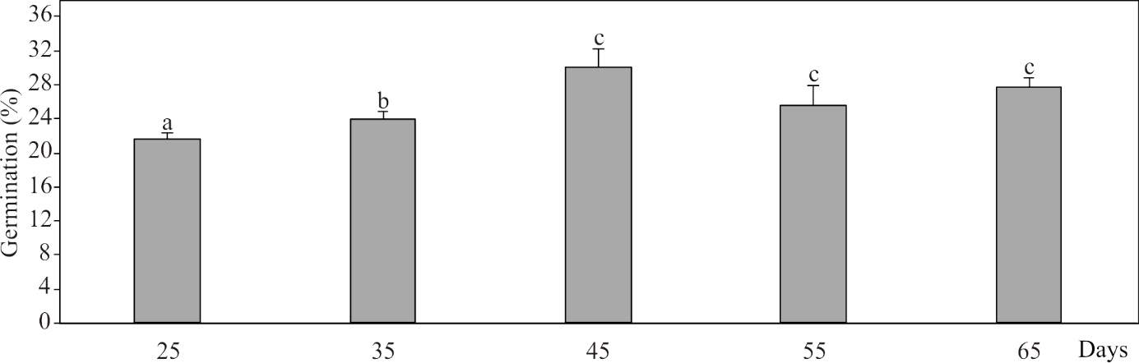

Figure 1. Germination of gyrogonites of *Chara intermedia* originating from the sediments during experiment; different letters indicate statistically significant differences (p=0.05)

In the case of gyrogonites taken from the thallus, after twenty-five days of the experiment, more than 5% of germinating gyrogonites were found (Fig. 2). In the following days of observation, the percentage of germinating gyrogonites in the range of 6-9%; because of the large variability of the data, the differences between the values of this parameter were not statistically signiﬁcant (Fig. 2).

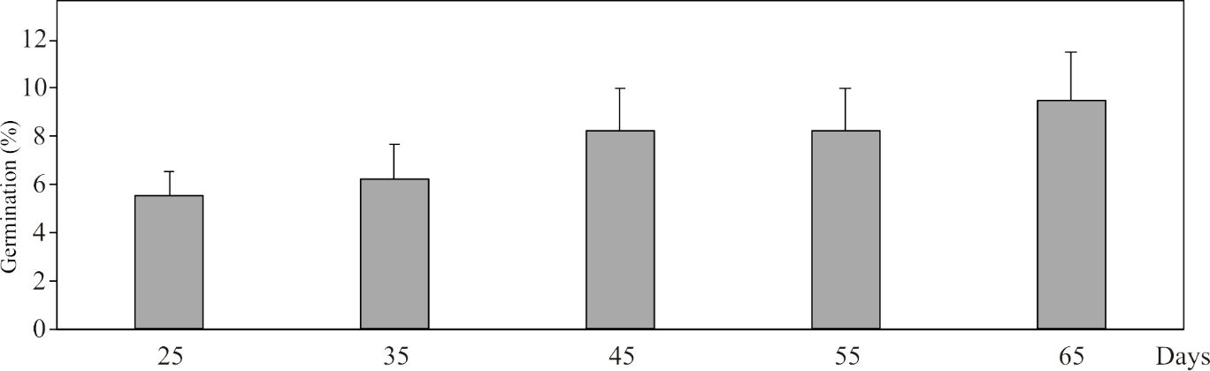

Figure 2. Germination of gyrogonites produced by the thalli *Chara intermedia* during experiment

Germination of gyrogonites in oosporangium remains was initiated only thirty-five days after the beginning of the experiment, and their percentage share was over 1% (Fig. 3). Twenty days later, the rate of oospore germination was about 3%. The highest germination percentage of these gyrogonites was noted at the end of the experiment (about 5%), and statistically significant differences were found.

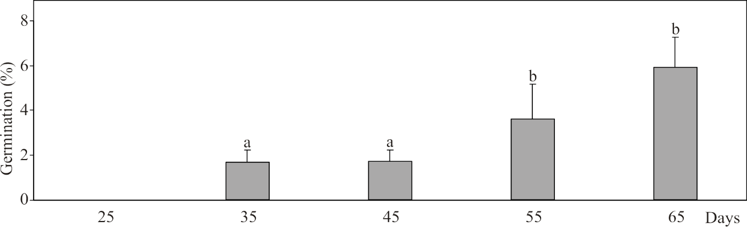

Figure 3. Germination of *Chara intermedia* gyrogonites in oosporangium remains during experiment; different letters indicate statistically significant differences (p=0.05)

Based on the experimental observations, it was found that gyrogonites in the oosporangium remains were characterized by the lowest ability of germination (an average of 1%), and the highest germination ability was exhibited by gyrogonites recovered from the underwater seed bank (Fig. 4). At the end of the experiment, about 28% of germinating gyrogonites from the sediments were observed, and their ability of germination was 3-fold higher than that of gyrogonites produced by the thalli and more than 5-fold higher in relation to gyrogonites produced by the thalli in oosporangium remains (Fig. 4).

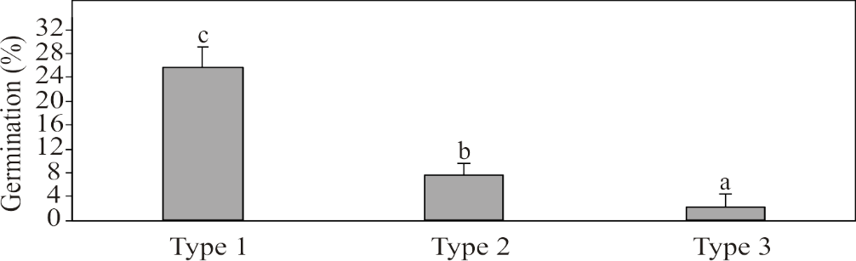

Figure 4. Comparison of the germination ability (%) of the selected gyrogonites of *Chara intermedia* at the end of the experiment; type 1 – gyrogonite from the sediments; type 2 – gyrogonite from the thallus; type 3 – gyrogonite from the thallus in oosporangium remains; different letters indicate statistically significant differences (p=0.05)

DISCUSSION

Gyrogonites are extremely sensitive to light as a germination trigger (36, 40, 43). Germination can proceed without a requirement for light (23). Hence, there are relatively few experimental studies concerning germination of charophytes in the dark (36, 40, 43).

De Winton et al. (14) suggest that germination is possible in the absence of light exposure, which is in accordance with the results of the present studies (Fig. 1-4). Also, the data for the other species show that germination in the dark of oospores of *Nitella furcata* ssp. *megacarpa* is successful (7.9%) (35). In our experiment conducted in the dark conditions, the rate of germination was several times higher and amounted to 30% (Fig. 1). Thus, a short impulse of light is sufficient to trigger germination of charophytes in the dark.

Nevertheless, light is required to activate germination following the phase of dormancy (35). Dormant oospores are not capable of germination. This is important in the case of prevailing disadvantageous conditions (desiccation or winter) (7, 29). Generally, fresh oospores, i.e. those produced during the growing season, show deeper secondary dormancy than those originating from sediments (43). Our study results indicate that the gyrogonites produced by the thalli are probably in secondary dormancy. This fact is evidenced by the low germination during the experiment. The average germinability of gyrogonites produced by plants was over 3-fold lower than the average germinability of the theoretically older gyrogonites found in the sediments (Fig. 4).

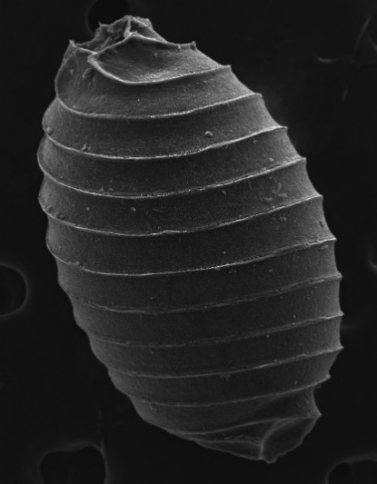

a

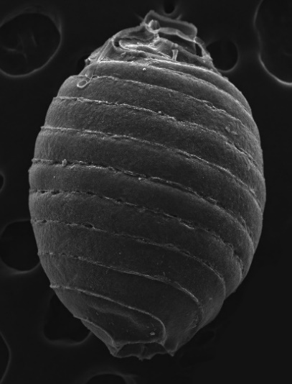

b

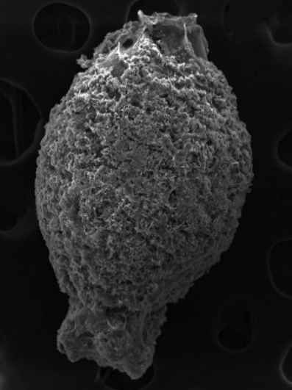

c

200 µm

200 µm

200 µm

Figure 5. *Chara intermedia* gyrogonites; (a) type 1 – gyrogonite from the sediments; (b) type 2 – gyrogonite from the thallus; (c) type 3 – gyrogonite from the thallus in oosporangium remains

The disadvantageous habitat conditions prevailing in shallow water bodies can have a significant impact on the degree of oospore maturity and morphological diversity (Fig. 5). This results in diverse germinability of diaspores (Fig. 2-3). According to the researchers of this subject, except the morphological aspects of gyrogonites, crucial is the knowledge relating the ecological conditions leading to the formation of oospores, calcification of the fertilized oogonium, and finally the formation of gyrogonites (37). For most species of charophytes, after the oospore has been formed, the process of maturation and formation of gyrogonite is continued (17, 37). The unpredictable habitat conditions in the post-excavation pit in summer 2015 led to appearance of charophytes above the water surface. The low water level in the peat pit caused drying of *C. intermedia* thalli; consequently, different morphological types of body plants developed, which characterized different degree of maturity and germinability. Probably, gyrogonites in oosporangium remains need additional time to mature. This may be the major cause of their delayed germination (Fig. 2-3).

Summing up, disadvantageous habitat conditions prevailing in shallow water bodies can have a significant effect on the degree of oospore maturity and morphological variability. The two distinguished morphological types of gyrogonites collected from the thalli are characterized by different degrees of maturity and germination ability, while those deposited in sediments may affect the structure and properties of the underwater seed bank.

REFERENCES

1. Blindow I. 1991. Reasons for the decline of Charophytes in eutrophicated lakes in Scania (Sweden). Extant and Fossil Charophytes. Bull. Soc. Bot. France 138; 95.
2. Blindow I. 1992. Decline of charophytes during eutrophication: comparison with angiosperms. Freshwater Biol. 28; 9-14.
3. Bonis A., Grillas P. 2002. Deposition, germination and spatio-temporal patterns of charophyte propagule banks: a review. Aquat. Bot. 72; 235-248.
4. Brock M.A., Lane J.A.K. 1983. The aquatic macrophyte flora of saline wetlands in Western Australia in relation to salinity and permanence. Hydrobiologia 105; 63-76.
5. Casanova M.T. 1994. Vegetative and reproductive responses of charophytes to water-level fluctuations in permanent and temporary wetlands in Australia. Aust. J. Mar. Fresh. Res. 45; 1409-1419.
6. Casanova M. T., Brock M. A. 1990. Charophyte germination and establishment from the seed bank of an Australian temporary lake. Aquat. Bot. 36; 247-254.
7. Casanova M.T., Brock M.A. 1996. Can oospore germination patterns explain charophyte distribution in permanent and temporary wetlands? Aquat. Bot. 54; 297-312.
8. Casanova M.T, Brock M.A. 1999. Charophyte occurrence, seed banks and establishment in farm dams in New South Wales. Aust. J. Bot. 47; 437-444.
9. Casanova M.T., de Winton M.D., Clayton J.S. 2003. Do charophytes clear turbid water? Verh. Internat. Verein. Limnol. 26; 1440-1443.
10. Coops H. 2002. Ecology of charophytes: an introduction. Aquat. Bot. 72; 205-208.
11. Corillion R. 1957. Les Charophycées de France et d’Europe Occidentale Bulletin de la Société Scientifique de Bretagne 32; 1-259.
12. Corillion R. 1975a. Flore des Charophytes (Characées) du Massif Armoricain et des contrées voisines d'Europe occidentale. Flore et Végétation du Massif Armoricain Tome IV. Paris.
13. Dąmbska I. 1964. Charophyta – ramienice. Flora Słodkowodna Polski. PWN Warszawa.
14. De Winton M.D., Casanova M.T., Clayton J.S. 2004. Charophyte germination and establishment under low irradiance. Aquat. Bot. 79; 175-187.
15. Feist M., Grambast-Fessard N., Guerlesquim M., Karol K., Lu H., McCourt R. M., Wang Q., Zang S. 2005. Treatise on invertebrate paleontology, Part B., Protoctista 1, volume 1: Charophyta. Geological Society of America and the University of Kansas Press, Lawrence KS; 175.
16. Forsberg C. 1965. Sterile germination of *Chara* and seeds of *Najas marina*. J. Plant Physiol. 18; 129-137.
17. García A., Chivas A.R. 2004. Quaternary and extant euryhaline *Lamprothamnium* Groves (*Charales*) from Australia: gyrogonite morphology and paleolimnological significance. J. Paleolimnol. 31; 321-341.
18. Grambast L.J. 1974. Phylogeny of the Charophyta. Taxon 23; 463-481.
19. Haas J.N. 1994. First identification key for charophyte oospores from central Europe. Eur. J. Phycol. 29; 227-235.
20. Henderson G.T. 1961. Some factors affecting oospore germination in *Chara zeylanica* Willdenow 39.
21. Horn af Rantzien H. 1956. Morphological terminology relating to female charophyte gametangia and fructifications. Bot. Notiser 109; 212-259.
22. Kalin M., Smith M.P. 2007. Germination of *Chara vulgaris* and *Nitella flexilis* oospores. What are the relevant factors triggering germination? Aquat. Bot. 87; 235-241.
23. Krause W. 1981. Characeen als Bioindikatoren für den Gewässerzustand. Limnologica 13; 399-418.
24. Kufel L., Kufel I. 2002. *Chara* beds acting as nutrient sinks in shallow lakes – a review. Aquat. Bot. 72; 249-260.
25. Olsen S. 1945. The vegetation in Præstø Fjord, 1. Spermatophyta and charophyta. In K. Hansen (1953). Investigations of the geography and natural history of the Præstø Fjord, Zealand, Folia Geographica Danica. 3 (4); 84-130.
26. Ozimek T. 2006. The possibility of submerged macrophyte recovery from a propagule bank in the eutrophic Lake Mikołajskie (North Poland). Hydrobiologia 570; 127-131.
27. Pełechaty M., Gąbka M., Sugier P., Pukacz A., Chmiel S., Ciecierska H., Kolada A., Owsianny P.M. 2009. *Lychnothamnus barbatus* in Poland: habitats and associations. Charophytes 2(1); 13-18.
28. Perrow M.R., Meijer M.L., Dawidowicz P., Coops H. 1997. Biomanipulation in shallow lakes: state of the art. Hydrobiologia 342/343; 355-365.
29. Proctor V.W. 1967. Storage and germination of *Chara* oospores. J. Phycol. 3; 90-92.
30. Rodrigo M.A., Alonso-Guillen J.L., Soulié-Märsche I. 2010. Reconstruction of the former charophyte community out of the fructifications identified in Albufera de València lagoon sediments. Aquat. Bot. 92; 14-22.
31. Rodrigo M.A., Rojo C., Segura M., Alonso-Guillén J.L., Martín M., Vera P. 2015. The role of charophytes in a Mediterranean pond created for restoration purposes. Aquat. Bot. 120; 101-111.
32. Sabbatini M.R., Argüello J.A., Fernández O.A., Bottini R.A. 1987. Dormancy and growth-inhibitor levels in oospores of *Chara contraria* A. Braun ex Kütz. (Charophyta). Aquat. Bot. 28; 189-194.
33. Schwarz A.M., Hawes I., Howard-Williams C. 1996. The role of the photosynthesis/light relationship in determining lower depth limits of Characeae in South Island. New Zealand lakes. Freshwater Biol. 35, 69-80.
34. Sederias J., Colman B. 2007. The interaction of light and low temperature on breaking the dormancy of *Chara vulgaris* oospores. Aquat. Bot. 87; 229-234.
35. Sokol R.C., Stross R.G. 1986. Annual germination window in oospores of *Nitella furcata* (Charophyceae). J. Phycol. 22; 403-406.
36. Sokol R.C., Stross R.G. 1992. Phytochrome mediated germination of very sensitive oospores. J. Plant Physiol.100; 1132-1136.
37. Soulié-Märsche I., Garciá A. 2015. Gyrogonites and oospores, complementary viewpoints to improve the study of the charophytes (Charales). Aquat. Bot. 120; 7-17.
38. Spence D.H.N. 1976. Light and plant response in fresh water. In G.C. Evans. Bainbridge R., Rackham O. (eds). Light as an ecological factor: II, Blackwell Scientific Publications. Oxford; 93-133.
39. Stobbe A., Gregor T., Röpkea A. 2014. Long-lived banks of oospores in lake sediments from the Trans-Urals (Russia) indicated by germination in over 300 years old radiocarbondated sediments. Aquat. Bot. 119; 84-90.
40. Stross R.G. 1989. The temporal window of germination in oospores of *Chara* (Charophyceae) following primary dormancy in the laboratory. New Phytol. 113; 491-495.
41. Sugier P. 2014. Ecological Processes and Properties of Excavated Peatlands of Eastern Poland. Towarzystwo Wydawnictw Naukowych LIBROPOLIS. Lublin, 170.
42. Sugier P., Pełechaty M., Gąbka M., Owsianny P. M., Pukacz A., Ciecierska H., Kolada A. 2009. *Lychnothamnus barbatus*: global history and distribution in Poland. Charophytes 2(1); 19-24.
43. Takatori S., Imahori K. 1971. Light reactions in the control of oospore germination of *Chara delicatula*. Phycologia 10; 221-228.
44. Urbaniak J., Sugier P., Gąbka M. 2011. Charophytes of the Lubelszczyzna Region (Eastern Poland). Acta Soc. Bot. Pol. 80(2); 159-168.
45. Van den Berg M.S., Scheffer M., Coops H., Simons J. 1998. The role of characean algae in the management of eutrophic shallow lakes. J. Phycol. 34; 750-756.
46. Van den Berg M.S., Scheffer M., van Nes E.H., Coops H. 1999. Dynamics and stability of *Chara* sp. and *Potamogeton pectinatus* in a shallow lake changing in eutrophication level. Hydrobiologia 408; 335-342.
47. Van Donk E., van de Bund W.J. 2002. Impact of submerged macrophytes including charophytes on phyto- and zooplankton communities: allelopathy versus other mechanisms. Aquat. Bot. 72; 261-274.
48. Wang H.Yu.D., Xiao K. 2008. The interactive effects of irradiance and photoperiod on *Chara vulgaris* L.: concerted responses in morphology, physiology, and reproduction. Hydrobiologia 610; 33-41.
49. [www.en.tutiempo.net](http://www.en.tutiempo.net)