The Circular Economy principles: A theoretical and definitional exploration within the European Union framework

Keywords: circular economy; sustainable development; ESG; CEBM; CSRD
JEL: O13, P48, E01, K32, O44

How to quote this paper: Osiecka-Brzeska, K., Próchniak, J., & Czerepko, J. (2024). The transition of companies towards Circular Economy principles: A theoretical and definitional exploration within the European Union framework. Annales Universitatis Mariae Curie-Skłodowska, sectio H – Oeconomia, Vol. XYZ, No. (Times New Roman, 8 pt, left-aligned)

Abstract

Theoretical background: The concept of circular economy (CE) emerged in 1970 and gained popularity in the early 21st century, particularly in European Union (EU), China, and India. CE is a response to resource depletion and environmental degradation. As CE aims to maintain the usability of products and materials while minimizing waste, its incorporation into regulations and policies is driven by the need for sustainability and effective waste management. The study analyses main scientific papers from 1970 to 2024 to show changes in terminology, understanding, and interpretation of the main components of the idea of circularity.
Purpose of the article: This paper examines the consistency of circular economy research principles with the regulatory framework, assessing the conceptual aspects and scope of the CE as presented in EU documents. Research methods: The research method was desk-based, using formal regulations and research frameworks based on the Scopus and Web of Science databases. Mainly academic studies and legal acts were evaluated.
Main findings: Over time, the scope of the circular economy definition changes. Among other things, a significant increase in formal and legal regulations for companies can be seen from 2020 onwards. The number of studies has also grown rapidly in recent years. While the definition of CE has not changed significantly, there have been major changes in the key areas of activity and scope. We systemize the regulatory aspects of CE by: circular economy definition boundaries, values, targets and reporting. The original nature of this article is to organise the knowledge on CE contained in the literature and source documents of the European Union. The study will enable the promotion of knowledge on circularity by structuring the terminology and indicating the thematic scope of CE in different documents. Given the social context, the article can be used to raise awareness of the circular economy among consumers, enabling them to make more informed choices when selecting products and services.

The transition of companies towards Circular Economy principles: A theoretical and definitional exploration within the European Union framework

Keywords: circular economy; sustainable development; ESG; CEBM; CSRD
JEL: O13, P48, E01, K32, O44

Introduction
The circular economy (CE) appears in many European Union documents as a desirable business model for sustainable organisations. It means moving away from a linear economic model that relies on the consumption of resources to make products that end up in landfills. The circular approach assumes that what was previously waste can still be a resource or product through circular processes such as recovery, but also reuse, refurbishment, reuse and repair (Potting et al., 2017).
One element of the introduction of the CE is the European Green Deal - a package of policy initiatives aimed at ESG reporting, which is intended to put the EU on the path to a green transition and ultimately achieve climate neutrality by 2050 (Official European Council of the European Union). Over the past few years, more Green Deal-related regulations have gradually been introduced. One of the most recent documents is the Corporate Sustainability Reporting Directive – CSRD (Directive (EU) 2022/2464) and the European Sustainability Reporting Standards, which set standards for environmental, social and governance (ESG) reporting. ESG reporting includes disclosures related to the transition to a circular economy and resource use in the Environment (E) area of the European Sustainability Reporting Standard (ESRS). Therefore, the transition already applies to companies at the level of their business model and development strategy from 2024 onwards. The purpose of this paper is to assess the relationship between circular economy theory and the perspective derived from European Union documents related to business. Due to formal regulations, an analysis of foundational data was adopted as the main method. Mainly academic studies and legal acts were assessed.
Literature review
Circular economy is a very broad concept, which has increased rapidly in research recently. More than 31,000 papers containing the term 'circular economy' have been published from the Scopus database since 1990. By 2010, fewer than 10 papers per year were published. More than 100 papers were published for the first time in 2010. This sudden growth is visible after a year of 2018 - there were already nearly 1,400 such papers, whilst in 2021 – more than 5,300, in 2022 – more than 6,500, and nearly 8,000 in 2023. Over this whole period, only 7.1% (5074) of all documents fall under Business, Management and Accounting.

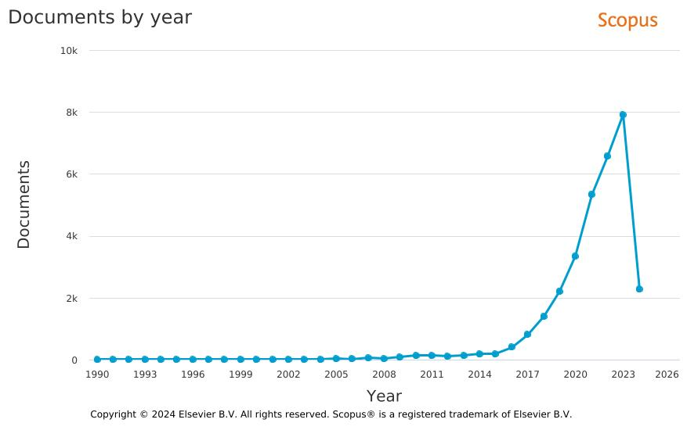
Figure 1. Number of scientific papers regarding Circular Economy by year in Scopus

Source: Scopus

The map of topics and their relationships published in Web of Science research papers is shown in Figure 2. The relationship between topics is determined by documents that cover the same topics. The size of the bubble varies according to the number of documents containing the topic, while the arrows indicate which topics refer to each other. The most relevant publication contexts were related to greenhouse gas emissions and life cycle assessment.
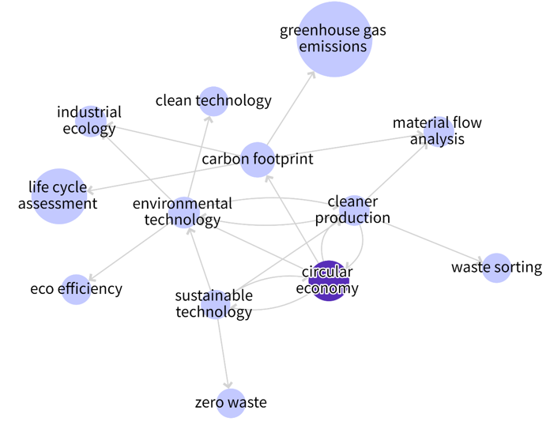

Figure 2. The map of topics related to circular economy
Source: Prepared using the Web of Science Research Assistant

Although, some studies refer to the1940s’ food industry evolution (Glover et al., 2014), or to the 1930s’ concept by Leontief (Witjes & Lozano, 2016), the concept of a circular economy has been widely developed since the 1990s. The origin of the term is assigned to the economic model created by Pearce & Turner in 1990 in the context of the principle that 'everything is an input to everything else' (Glover et al., 2014; Rizos et al., 2017). However, in the prevailing opinion of studies, the circular concept initiated in the 1960s regarding the environmental risks (Piwowar-Sulej, 2021) and industrial ecology (Le Tellier et al., 2019). Another approach identifies as a base date the 1970s’ tracing the oil crisis (Chatterjee et al., 2021; Ciulli & Kolk, 2019; Davies et al., 2017; Durst & Zieba, 2020; Garretson et al., 2017).
Despite the time, there is no consensus on defining circular economics. The term is most often presented as a combination of reduction, reuse, and recycling activities, while it is often not emphasized that CE requires systemic change (Kirchherr et al., 2017). Researchers notice that CE is a ‘regenerative system in which resource input and waste, emission, and energy leakage are minimized by slowing, closing, and narrowing material and energy loops through Rs strategies’ (Geissdoerfer et al., 2017). Those strategies were integrated by the 3Rs concept of (Reduce, Reuse, Recycle) (Piwowar-Sulej, 2021; Bai et al., 2020, Korhonen et al., 2018), then the 7Rs (Rethink, Reduce, Reuse, Repair, Refurbish, Recover, Recycle) and 10Rs by adding Refuse, Remanufacture and Re-mine (Shevchenko et al., 2023; Alvarez-Risco, Rosen, Del-Aguila-Arcentales, 2022). Yet, the concept is still being developed and changed, what effects with a change among Rs (Potting et al., 2017). In Figure 3, the levels of Rs in CE are related to the three areas. These fields illustrate stages of a product's lifespan: designing, usage and consumption, and end of life.
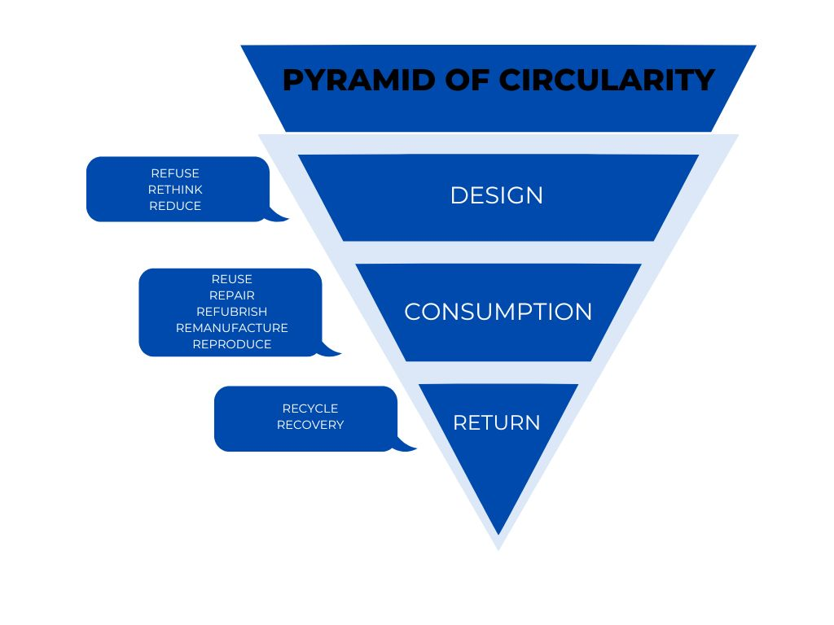
Figure 3. Levels of circularity: 10R’s
Source: Cramer. J., Building a Circular Future Ten Takeaways for Global Changemakers, Amsterdam Economic Board, ISBN 978-90-9035608-2

Another approach shows circular economy in the business models of companies, in which context it refers to a change in entities. This economic model leads to a waste-free system that adheres to three principles: (1) preserve natural capital, (2) optimize resource yields by circulation of products and components at the highest utility, (3) foster system effectiveness by reducing the negative externalities (Towards a circular economy, 2015). In the business model, the circular economy is linked to technological development. One of the needs in the transition to CE is eco-innovation, which closes the loop of products' lifecycle, gets value from waste, and addresses the need for environmental resilience despite growth trends (Prieto-Sandoval et al., 2018). Many business practices and considerations are being analyzed in terms of circularity, such as digitalization and digital technologies (Gregori & Holzmann, 2020; Luzzini et al., 2015; Piwowar-Sulej, 2021), sustainable innovation (Brix, 2020), sustainable consumption (Frostenson et al., 2022; Curtis & Mont, 2020; Viciunaite & Alfnes, 2020; Witjes & Lozano, 2016), managing resource loop (Dijkstra et al., 2020; Le Tellier et al., 2019; Heyes et al., 2018; Hess, 2014), closed-loop systems (van Rijnsoever, 2022; Zhao et al., 2022; Ciulli & Kolk, 2019; Mellor et al., 2014), cradle-to-cradle product approach (Dijkstra et al., 2020), or shared services, green human resource management.
The CE received a lot of attention in the context of sustainable organizations and their dynamic capabilities to implement new business models in a complex environment (Curtis & Mont, 2020; Santa-Maria et al., 2022). The concept of the circular economy is widely recognized as a trigger for the transformation of business models (Tura et al., 2019), leading to circular business models - CBMs (Heyes et al., 2018) that include circular products, reverse cycles, new frameworks, and transition in consumption models from owners to end-users.
The circular economy includes the transition from linear to sustainable practices (Brix, 2020). Among the crucial aspects, restorative and regenerative production, and industrial systems that should lead to resource efficiency are emphasized (Frostenson et al., 2022; Heyes et al., 2018; Korhonen et al., 2018). Hence, the circular economy is most commonly seen through the prism of manufacturing and production (Piwowar-Sulej, 2021; Tecchio et al., 2017; Weissbrod & Bocken, 2017) with a focus on cleaner production (Brix, 2020; Durst & Zieba, 2020). Transportation (Bögel et al., 2019), building and construction sectors (Le Tellier et al., 2019; Tecchio et al., 2017), food (Bai et al., 2020; Berg, 2000; Glover et al., 2014), services (Frostenson et al., 2022), fashion and textile industry (de Brito et al., 2008) or agriculture (Dubey et al., 2017) are mentioned widely in terms of circular economy.
Some studies indicate CE implementation barriers such as: high production and marketing costs, lack of consumers’ interest, limited knowledge of CE design, limited availability of circular supply streams, regulatory barriers, and limitations of experimental practices (Hartley et al., 2022). Depending on the place where barriers appear, they may be divided into internal (company's policies and strategies, financial, technological, lack of resources, collaborations, product design, internal stakeholders) and external (consumers-related, legislative and economic, supply chain-related, socialism cultural, and environmental) (Hina et al. 2022). The external barriers are often extended to market, institutional, and regulatory, as well as economic (Bianchini et al., Hart et al), while internal ones may be associated with the managerial approach, policy and regulatory, customers, and performance indicators (Galvão et al., 2018). Nevertheless, academics notice insufficient knowledge about the adoption and implementation of the circular approach, especially in different sectors and small companies (Heyes et al., 2018; Stål & Corvellec, 2018). Furthermore, circular economy issues are not sufficiently taken into account in strategic thinking.
Research methods
This study performs an expository explanation of circular economy concept using the desk-based research. The authors analysed various European Union documents to assess the coherence of the CE approach within the regulations and policies and to organize the terminology associated with it, thus broadening the perspective on theoretical studies on circularity and its confirmation in practice. A scoping literature search was implemented using the Scopus database. The explanatory keyword ‘circular economy’ was exercised. As a result of the regulatory considerations were ordered in topics: definition, values, goals, reporting requirements. The study regulatory conclusions were compiled with attention to the conclusions of the academic studies analysis. Records of acts, strategies and publications were systematically analysed using strategic and critical reading methods. Figure 4 shows the chronology of the documents and acts analysed.
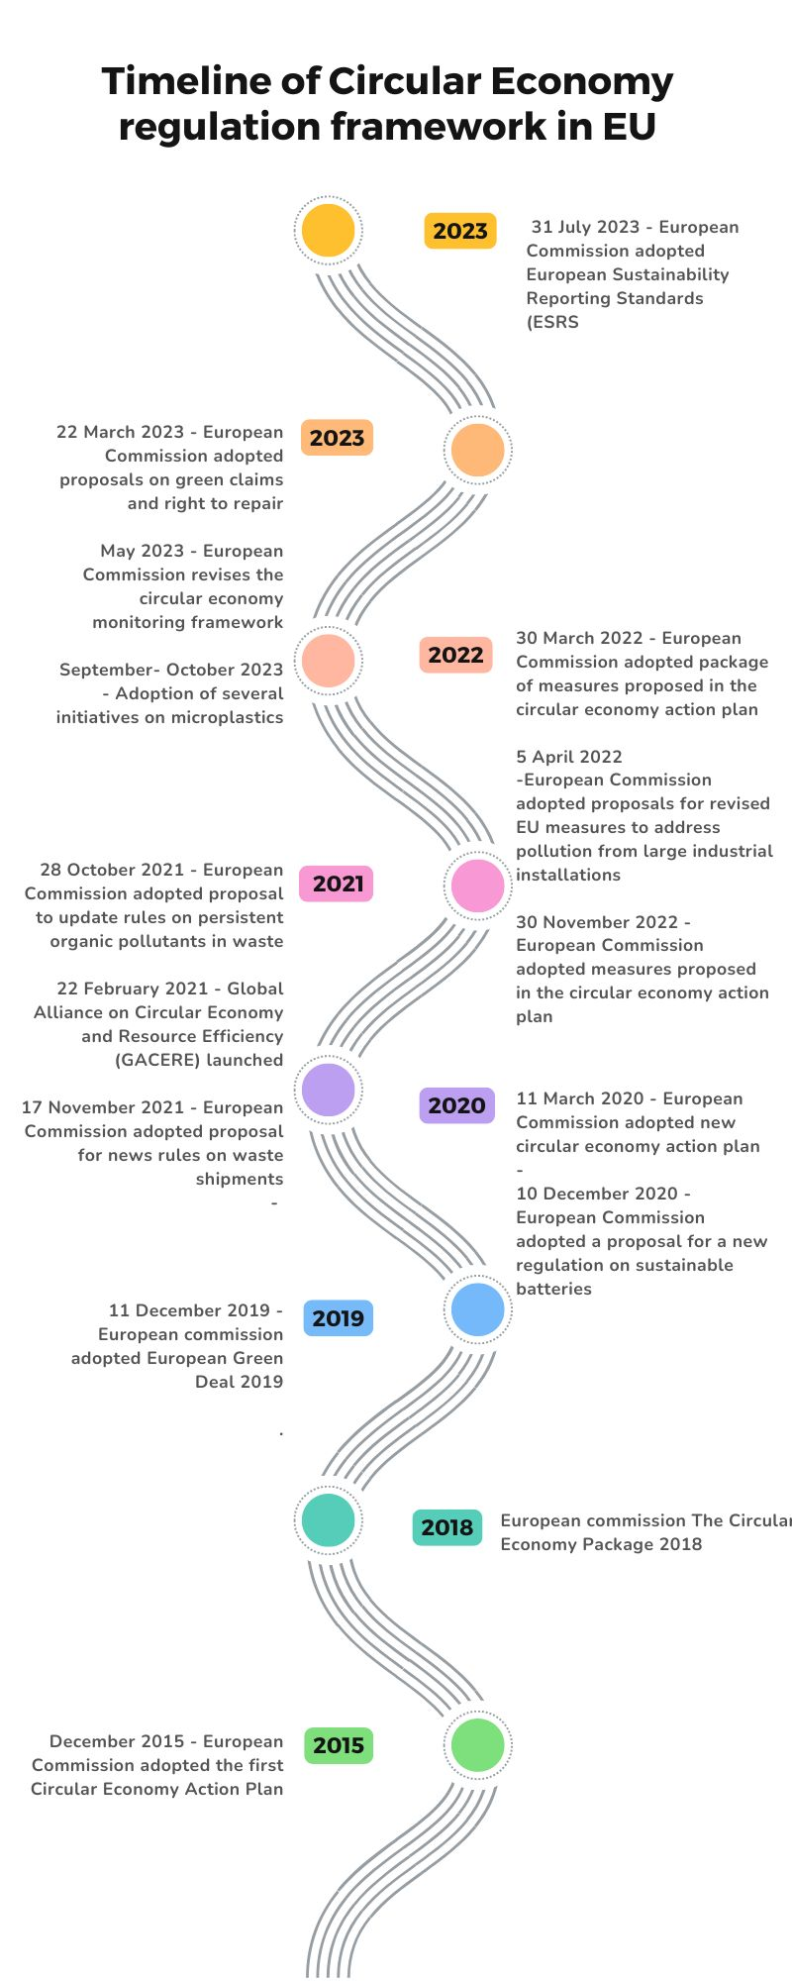
Figure 4. Timeline of Circular economy regulation framework
Source: Own elaboration based on Circular economy action plan - European Commission (europa.eu).
Results
The analysis of EU legislation gives a picture of a well thought-out policy that has evolved over time. The first documents focus on defining the idea and role of the EU in achieving sustainable development goals through the implementation of a circular economy. Over time, the documents specify the concepts, objectives and individual tasks to be implemented by individual EU Member States and their subordinate bodies. The most recent documents not only relate to organizations at the macro level, but also go down to the micro level - they oblige companies operating in the EU to take action for circularity. Taken together, the documents create a holistic vision of a European economy that is environmentally friendly, provides resources for entrepreneurs and cares for the quality of life of society. Analysis of the EU documents reveals changes in the approach to circularity, summarized in Figure 5.
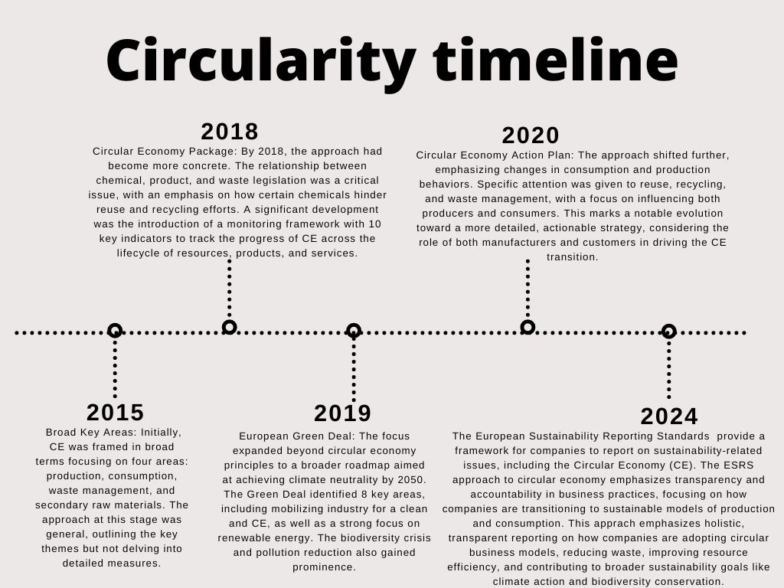

Figure 5. Circularity diagram
Source: Own elaboration based on EU’s Circular economy regulation framework.
Analysis of the text of EU documents allows us to outline four key areas of legislative focus. The first is the limits of CE regulation, which define circularity and thus the scope of regulation. The next important area is values, which identify areas where circularity plays an important role. Objectives define the main goals that the European Union wants to achieve by implementing the idea of a circular economy. The last, but equally important, area is Reporting, which is the most prominent in the legislation and allows us to monitor the degree and direction of implementation of the above areas.
CE concept boundaries
The concept of the circular economy has been defined and redefined in various EU documents, each highlighting slightly different aspects of the framework depending on the context and objectives of the document. The Circular Economy Packages of 2015 and 2018 focus on resource loops and waste minimization, presenting a fundamental view of CE. This approach is related to the 10Rs theory mentioned above. The 2020 Action Plan includes more societal and economic dimensions, suggesting that CE is critical for climate neutrality and digital innovation. The ESRS E5 (2023/2024) provides the most comprehensive definition, focusing on preserving the value of resources, minimizing environmental impact and efficient use in a broader economic context. In summary, definitions are evolving from a primarily resource-focused approach in earlier documents to a systemic and economic approach in more recent documents, integrating environmental, social and technological dimensions.
Values
The values and key action areas related to CE in EU documents reflect the evolving priorities and broader objectives of the European Union, which is in line with the EU's overall sustainable development policy. The 2015 and 2018 packages focus on the basics of waste reduction and efficient resource management, with the 2018 version extending to regulatory measures. The European Green Deal broadens the scope of circularity to include climate, energy, biodiversity and pollution issues, integrating circular economy principles into broader environmental and economic policies. The 2020 Action Plan prioritises key value chains and emphasises sector-specific actions in industries such as electronics, textiles and construction, while aiming to change consumption and production patterns. The ESRS E5 document presents the most holistic and systemic vision of the circular economy, emphasising the need for a resilient, sustainable and regenerative economic system that decouples growth from resource extraction and creates new economic opportunities. In conclusion, the EU's circular economy values are evolving from a waste reduction framework (2015) to a comprehensive, climate-linked strategy (Green Deal, 2020 Action Plan) and finally to a holistic economic transformation model (ESRS E5, CSRD).
Goals
The goals out in the EU's circular economy policy documents reflect their specific focus and the broader context in which they were developed. The 2015 Circular Economy Package focuses on setting regulatory targets for landfill, reuse and recycling, with specific measures to be achieved by 2030. The 2018 Circular Economy Package shifts towards addressing a critical environmental issue - plastic waste - by focusing on transforming its design, production and recycling processes. The European Green Deal has broader ambitions, aiming to transform the entire European economy for a sustainable future, with a strong focus on climate neutrality, innovation and financing the green transition. The 2020 Action Plan emphasises closing the loop by transitioning to a fully circular economy, focusing on sustainable business models and increasing Europe's competitiveness through circular practices. The ESRS E5 (2023/2024) has the most specific targets, focusing on corporate reporting and transparency, with a focus on understanding the financial and strategic implications of resource use and circular economy practices for companies. It sets standards for disclosure to ensure alignment with circular principles. In summary, previous documents (2015, 2018) focus on sector-specific targets such as waste management and plastics transformation. The Green Deal and the 2020 Action Plan aim for broader systemic change, focusing on the transformation of the whole economy. ESRS E5 sets corporate accountability as its main objective, ensuring that companies align their strategies with circular economy principles and report on the financial impact of these practices.
Reporting
Reporting on circularity varies significantly across EU documents, reflecting the evolving complexity of the circular economy agenda and the mechanisms for tracking progress. The 2015 Circular Economy Package focuses on action plans and legislative proposals, with little emphasis on detailed reporting. The 2018 Circular Economy Package takes a reporting approach, assessing the implementation of the original 2015 action plan, making it more analytical and reflective of progress. The European Green Deal provides a strategic roadmap, focusing on the investments needed for long-term goals, but does not provide detailed reporting specific to the circular economy. The 2020 Action Plan focuses on the systemic transformation of product policy and consumption patterns, offering a set of initiatives rather than a structured reporting or evaluation mechanism. ESRS E5 (2023/2024) is the most comprehensive in terms of reporting, with a structured annual report based on a large set of quantitative indicators to track circular economy progress in detail. In summary, the earlier documents focus on action plans and strategic initiatives, while the latest reports, such as ESRS E5, introduce more detailed, quantitative reporting frameworks to systematically monitor and evaluate circular economy progress.
Discussion
Given the historical overview, it is clear that legislative work on the transition to a circular economy is intensifying. In the first period (2015-2019), only three documents were published on the circular economy in the economy. Between 2020 and 2023, there was a significant increase in the number of regulations introduced, with two to four papers appearing per year (12 in total). The increase in the number of papers is reflected in the growing number of scientific publications - and thus in the growing interest in the topic of CE in the scientific world. A dynamic growth can be observed from 2020 onwards (2018: ~1,400 articles, 2021: ~5,300, 2022: ~6,500, 2023: ~8,000).
Approaches to CE have changed over time. In terms of key action areas, in 2015 these were very broadly defined as production, consumption, waste management and secondary raw materials. The Circular Economy Package 2018 takes a more concrete approach (the relationship between chemicals, products and waste legislation; how some chemicals can hinder reuse and recycling and the transition to a circular economy; monitoring framework - a set of ten key indicators to assess the progress of the transition to a circular economy at each stage of the life cycle of resources, products and services in this package). The European Green Deal (2019) focuses on a roadmap to improve efficiency in resource use, restore biodiversity, reduce pollution and outlines the investments needed to transition to a climate neutral Europe by 2050. The circular economy context is again taken up in a broader sense. In addition, 8 key areas have been identified, including mobilising industry for a clean and circular economy. Renewable energy sources have also received a lot of attention. In the Circular Economy Action Plan (2020), the focus of the approach is on changing consumption and production behaviour through reuse and recycling, as well as waste management. The approach shifts from a generic nature to specific detailed changes in the behaviour of producers and consumers. It is interesting to see a two-pronged approach to the problem - from both the producer's and the consumer's perspective.
It is not only the increasingly complex regulatory environment and the growing number of publications that demonstrate the relevance of the issue. The transition to a circular economy will be one of the most challenging elements of the changes in the business environment introduced by the ESG. The ESRS E5 directly requires companies' business plans to adapt their strategies and business models to the principles of the circular economy (such as minimizing waste, maintaining the value of products, materials and other resources at their highest value by increasing their efficient use in production) (ESRS E5, 2024).
This approach contrasts with the linear economy that has been in place since the Industrial Revolution. It requires a rethink not only of operations but also of supply chains in terms of circularity. While it is one of many criteria for sustainability reporting, it represents a major shift in the approach to planning and conducting business operations. The objective of this standard is broad: (1) to establish disclosure requirements that enable users of the sustainability statement to understand how the organisation manages its use of resources, including resource efficiency, prevention of resource depletion, and sustainable sourcing and use of renewable resources, in terms of material positive and negative impacts, actual or potential, (2) any actions taken and the results of such actions to prevent or mitigate actual or potential negative impacts arising from resource use, including the organisation's actions to contribute to decoupling economic growth from material use, and to address risks and opportunities, (3) and to report on the extent to which the organisation is meeting its sustainability objectives, (3) the company's plans and ability to adapt its strategy and business model in line with circular economy principles, including but not limited to minimising waste, maintaining the value of products, materials and other resources at their highest value and improving their efficient use in production and consumption, (4) the nature, type and extent of the company's material risks and opportunities related to the company's impacts and dependencies arising from resource use and the circular economy, and how the company manages them and (5) the financial implications for the organisation in the short, medium and long term of the material risks and opportunities arising from the organisation's impacts and dependencies on resource use and circularity (ESRS E5, 2024).
Conclusions
The circular economy is a very important area of ongoing change in the European market. Its main objective is to reduce the resource intensity of production and to become less dependent on resource extraction. The idea seems legitimate and its implementation is moving closer - through a series of legislative measures. There is also a clear shift from a more generic approach to one that forces changes in companies' business models. Further research into business and process modelling in the context of the move towards 'closing the loop' at business unit level therefore seems necessary. This is a major challenge as each company will have to adapt to the model individually and according to its capabilities.
References
Agrawal, R., Wankhede, V. A., Kumar, A., Upadhyay, A., & Garza-Reyes, J. A. (2022). Nexus of circular economy and sustainable business performance in the era of digitalization. International Journal of Productivity and Performance Management, 71(3), 748–774. https://doi.org/10.1108/IJPPM-12-2020-0676
Alvarez-Risco, A., Rosen, M.A., Del-Aguila-Arcentales, S. (2022). Closing Remarks. In: Alvarez-Risco, A., Rosen, M.A., Del-Aguila-Arcentales, S. (eds) Towards a Circular Economy. CSR, Sustainability, Ethics & Governance. Springer, Cham. https://doi.org/10.1007/978-3-030-94293-9_19
Arruda, E. H., Melatto, R. A. P. B., Levy, W., & Conti, D. de M. (2021). Circular economy: A brief literature review (2015–2020). Sustainable Operations and Computers, 2(May), 79–86. https://doi.org/10.1016/j.susoc.2021.05.001
Bai, C., Dallasega, P., Orzes, G., & Sarkis, J. (2020). Industry 4.0 technologies assessment: A sustainability perspective. International Journal of Production Economics, 229. https://doi.org/10.1016/j.ijpe.2020.107776
Berg, S. V. (2000). Sustainable regulatory systems: laws, resources, and values. Utilities Policy (Vol. 9). www.elsevier.com/locate/utilpol
Bianchini, A., Rossi, J., & Pellegrini, M. (2019). Overcoming the Main Barriers of Circular Economy Implementation through a New Visualization Tool for Circular Business Models. Sustainability, 11 (23), https://doi.org/10.3390/su11236614.
Bibas, R., Chateau, J., Dellink, R., & Lanzi, Elisa. (2019). Global Material Resources Outlook to 2060: Economic Drivers and Environmental Consequences. 10.1787/9789264307452-en.
Bocken, N. M. P., & Short, S. W. (2021). Unsustainable business models – Recognising and resolving institutionalised social and environmental harm. Journal of Cleaner Production, 312. https://doi.org/10.1016/j.jclepro.2021.127828
Bögel, P., Pereverza, K., Upham, P., & Kordas, O. (2019). Linking socio-technical transition studies and organisational change management: Steps towards an integrative, multi-scale heuristic. Journal of Cleaner Production, 232, 359–368. https://doi.org/10.1016/j.jclepro.2019.05.286
Bourguignon, D. (2016). Closing the loop – new circular economy package, European Parliament Research Service, PE 573.899, Brussels.
Brix, J. (2020). Building capacity for sustainable innovation: A field study of the transition from exploitation to exploration and back again. Journal of Cleaner Production, 268. https://doi.org/10.1016/j.jclepro.2020.122381
Chari, A., Niedenzu, D., Despeisse, M., Machado, C. G., Azevedo, J. D., Boavida-Dias, R., & Johansson, B. (2022). Dynamic capabilities for circular manufacturing supply chains—Exploring the role of Industry 4.0 and resilience. Business Strategy and the Environment, 31(5), 2500–2517. https://doi.org/10.1002/bse.3040
Chatterjee, I., Cornelissen, J., & Wincent, J. (2021). Social entrepreneurship and values work: The role of practices in shaping values and negotiating change. Journal of Business Venturing, 36(1). https://doi.org/10.1016/j.jbusvent.2020.106064
Cifuentes-Faura, J. (2022). European Union policies and their role in combating climate change over the years. Air Quality, Atmosphere & Health, 15(8), 1333-1340;
Ciliberto, C., Szopik-Depczyńska, K., Tarczyńska-Łuniewska, M., Ruggieri, A., & Ioppolo, G. (2021). Enabling the Circular Economy transition: a sustainable lean manufacturing recipe for Industry 4.0. Business Strategy and the Environment, 30(7), 3255–3272. https://doi.org/10.1002/bse.2801
Ciulli, F., & Kolk, A. (2019). Incumbents and business model innovation for the sharing economy: Implications for sustainability. Journal of Cleaner Production, 214, 995–1010. https://doi.org/10.1016/j.jclepro.2018.12.295
Communication From The Commission To The European Parliament, The Council, The European Economic And Social Committee And The Committee Of The Regions. A new Circular Economy Action Plan For a cleaner and more competitive Europe https://eur-lex.europa.eu/resource.html?uri=cellar:9903b325-6388-11ea-b735-01aa75ed71a1.0017.02/DOC_1&format=PDF
Consolidated text: European Parliament and Council Directive 94/62/EC of 20 December 1994 on packaging and packaging waste; Access current version (04/07/2018); ELI: http://data.europa.eu/eli/dir/1994/62/2015-05-26
Council Directive 1999/31/EC of 26 April 1999 on the landfill of waste; Current consolidated version: 04/07/2018; ELI: http://data.europa.eu/eli/dir/1999/31/oj
Cramer, J., (2022), Building a Circular Future Ten Takeaways for Global Changemakers, Amsterdam Economic Board, ISBN 978-90-9035608-2
Curtis, S. K., & Mont, O. (2020). Sharing economy business models for sustainability. Journal of Cleaner Production, 266. https://doi.org/10.1016/j.jclepro.2020.121519
Davies, I. A., Chambers, L., Maplecroft, V., & St, H. (2017). Integrating Hybridity and Business Model Theory in Sustainable Entrepreneurship.
Dijkstra, H., van Beukering, P., & Brouwer, R. (2020). Business models and sustainable plastic management: A systematic review of the literature. Journal of Cleaner Production, 258. https://doi.org/10.1016/j.jclepro.2020.120967
Directive (EU) 2022/2464 of the European Parliament and of the Council of 14 December 2022 amending Regulation (EU) No 537/2014, Directive 2004/109/EC, Directive 2006/43/EC and Directive 2013/34/EU, as regards corporate sustainability reporting
Directive (EU) 2018/849 of the European Parliament and of the Council of 30 May 2018 amending Directives 2000/53/EC on end-of-life vehicles, 2006/66/EC on batteries and accumulators and waste batteries and accumulators, and 2012/19/EU on waste electrical and electronic equipment (Text with EEA relevance); PE/9/2018/REV/1;
Directive 2000/53/EC on end-of life vehicles; European Parliament and Council of the European Union: Brussels, Belgium, 2000. https://eur-​lex.europa.eu/ legal-​content/EN/TXT/?uri=CELEX:32000L0053 Accessed 30 June 2020.
Directive 2008/98/EC of the European Parliament and of the Council of 19 November 2008 on waste and repealing certain Directives (Text with EEA relevance); ELI: http://data.europa.eu/eli/dir/2008/98/2018-07-05 (access: 28.03.2024)
Directive 2008/98/EC of the European Parliament and of the Council of 19 November 2008 on waste and repealing certain Directives (Text with EEA relevance); ELI: http://data.europa.eu/eli/dir/2008/98/2018-07-05 (access: 28.03.2024)
Durst, S., & Zieba, M. (2020). Knowledge risks inherent in business sustainability. Journal of Cleaner Production, 251. https://doi.org/10.1016/j.jclepro.2019.119670
ESRS E5, 2024 European Sustainability Reporting Standard E5 Resource Use and Circular Economy, EFRAG official document, available on: Working paper on draft ESRS E5 Resource use and Circular Economy vf.pdf (efrag.org)
European Commission (2015). “Communication of the Commission to the European Parliament, Council, European Economic and Social Committee and Committee of Regions “Closing the loop – the EU Action Plan for Circular Economy” (COM 2015)614 final, Brussels.
European Commission Website (2015a). Closing the Loop, Circular Economy: Boosting Business Reducing Waste, European Commission, Growth, Events. Online: http://ec.europa.eu/growth/toolsdatabases/newsroom/cf/itemdetail.cfm?item_id=8260&lang=en&title=Closing-theLoop---Circular-Economy%3A-boosting-business%2C-reducing-waste (access: 28.03.2025).
European Commission Website (2015b). Roadmap: Circular Economy Strategy. DG ENV (A1, A2, A3, F1); DG GROW. Online: http://ec.europa.eu/smartregulation/impact/planned_ia/docs/2015_env_065_env+_032_circular_economy_en.pdf (17/10/2015);
European Commission. Communication from the Commission to the European Parliament, the Council, the European Economic and Social Committee and the Committee of the Regions, A New Circular Economy Action Plan. For a Cleaner and More Competitive Europe, COM(2020) 98 fnal; European Commission: Belgium, Brussels, 2020. https://eur-​lex.europa.eu/legal-​content/EN/TXT/?uri=CELEX%3A520 20DC0098 Accessed 15 June 2020
European Parliament; EU climate target plan Raising the level of ambition for 2030; EPRS_BRI(2020)659370_EN.pdf (europa.eu);
Frostenson, M., Helin, S., & Arbin, K. (2022). Organizational sustainability identity: Constructing oneself as sustainable. Scandinavian Journal of Management, 38(3). https://doi.org/10.1016/j.scaman.2022.101229
Galvão, G.D.A., de Nadae, J., Clemente, D.H., Chinen, G., & Monteiro de Carvalho M. (2018). Circular Economy: Overview of Barriers, Procedia CIRP 73 (2018) pp. 79–85. https://doi.org/10.1016/j.procir.2018.04.011
García-Muiña, F., Medina-Salgado, M. S., González-Sánchez, R., Huertas-Valdivia, I., Ferrari, A. M., & Settembre-Blundo, D. (2021). Industry 4.0-based dynamic Social Organizational Life Cycle Assessment to target the social circular economy in manufacturing. Journal of Cleaner Production, 327. https://doi.org/10.1016/j.jclepro.2021.129439
Garretson, I. C., Mani, M., Leong, S., Lyons, K. W., & Haapala, K. R. (2017). Terminology to Support Manufacturing Process Characterization and Assessment for Sustainable Production. Journal of Cleaner Production 139(part A)
Geissdoerfer, M., Savaget, P., Bocken, N. M. P., & Hultink, E.J., (2017). The Circular Economy – A new sustainability paradigm? Journal of Cleaner Production, Vol. 143, pp. 757-768
Glover, J. L., Champion, D., Daniels, K. J., & Dainty, A. J. D. (2014). An Institutional Theory perspective on sustainable practices across the dairy supply chain. International Journal of Production Economics, 152, 102–111. https://doi.org/10.1016/j.ijpe.2013.12.027
Gregori, P., & Holzmann, P. (2020). Digital sustainable entrepreneurship: A business model perspective on embedding digital technologies for social and environmental value creation. Journal of Cleaner Production, 272. https://doi.org/10.1016/j.jclepro.2020.122817
Gyorgy, O., Claster Grouping of EU Member States According to Some Economic Performance and Circular Economic Indicators, Vadyba Journal of Management 2024, No 1(40), ISSN 1648-7974, https://doi.org/10.38104/vadyba.2024.1.02 , pp. 17-18.
Hart, J., Adams, K., Giesekam, J., Tingley, T.T., Pomponi, F. (2019). Barriers and drivers in a circular economy: the case of the built environment. Procedia CIRP, Vol. 80. ISSN 2212-8271. https://doi.org/10.1016/j.procir.2018.12.015.
Hartley, K., Roosendaal, J., & Kirchherr, J. (2022). Barriers to the circular economy: The case of the Dutch technical and interior textiles industries, Journal of Industrial Ecology 2022;26, pp. 477–490.
Hess, D. J. (2014). Sustainability transitions: A political coalition perspective. Research Policy, 43(2), 278–283. https://doi.org/10.1016/j.respol.2013.10.008
Heyes, G., Sharmina, M., Mendoza, J. M. F., Gallego-Schmid, A., & Azapagic, A. (2018). Developing and implementing circular economy business models in service-oriented technology companies. Journal of Cleaner Production, 177, 621–632. https://doi.org/10.1016/j.jclepro.2017.12.168
Hina M., Chauhan Ch., Kaur P., Kraus S., & Dhir A. (2022). Drivers and barriers of circular economy business models: Where we are now, and where we are heading, Journal of Cleaner Production 333 (2022) 130049
Institute for European Environmental Policy (IEEP). “Reaching sustainable consumption in Europe by 2050).” September 30, 2019. Accessed February 12, 2020. https://ieep.eu/news/reaching-sustainable-consumption-ineurope-by-2050.
Kirchherr, J., Reike, D., & Hekkert, M. (2017). Conceptualizing the circular economy: An analysis of 114 definitions, Resources, Conservation & Recycling 127, Elsevier, pp. 221–232.
Korhonen, J., Nuur, C., Feldmann, A., & Birkie, S. E. (2018). Circular economy as an essentially contested concept. Journal of Cleaner Production, 175, 544–552. https://doi.org/10.1016/j.jclepro.2017.12.111
Le Tellier, M., Berrah, L., Stutz, B., Audy, J.-F., & Barnabé, S. (2019). Towards Sustainable Business Parks: a Literature Review and a Systemic Model.
Luzzini, D., Brandon-Jones, E., Brandon-Jones, A., & Spina, G. (2015). From sustainability commitment to performance: The role of intra- and inter-firm collaborative capabilities in the upstream supply chain. International Journal of Production Economics, 165, 51–63. https://doi.org/10.1016/j.ijpe.2015.03.004
Matinheikki, J., Aaltonen, K., & Walker, D. (2019). Politics, public servants, and profits: Institutional complexity and temporary hybridization in a public infrastructure alliance project. International Journal of Project Management, 37(2), 298–317. https://doi.org/10.1016/j.ijproman.2018.07.004
Mazur-Wierzbicka E. (2021). Circular economy: advancement of European Union countries; Environmental Science Europe (2021) 33:111, doi.org/10.1186/s12302-021-00549-0, pp. 2-3.
Mellor, S., Hao, L., & Zhang, D. (2014). Additive manufacturing: A framework for implementation. International Journal of Production Economics, 149, 194–201. https://doi.org/10.1016/j.ijpe.2013.07.008
Mendoza, M. J. F., Sharmina, M., Gallego-Schmid, A., Heyes, G., & Azapagic, A. (n.d.). Integrating Backcasting and Eco-design for the Circular Economy: The BECE Framework.
Meseguer-Sánchez, V., Gálvez-Sánchez, F. J., Molina-Moreno, V., & Wandosell-Fernández-de Bobadilla, G. (2021). The Main Research Characteristics of the Development of the Concept of the Circular Economy Concept: A Global Analysis and the Future Agenda. Frontiers in Environmental Science, 9(July), 1–16. https://doi.org/10.3389/fenvs.2021.704387
Mishenin, Y., Koblianska, I., Medvid, V., & Maistrenko, Y. (2018). Sustainable regional development policy formation: Role of industrial ecology and logistics. Entrepreneurship and Sustainability Issues, 6(1), 329–341. https://doi.org/10.9770/jesi.2018.6.1(20)
Murray, A., Skene, K., & Haynes, K. (2017). The Circular Economy: An Interdisciplinary Exploration of the Concept and Application in a Global Context. Journal of Business Ethics, 140(3), 369–380. https://doi.org/10.1007/s10551-015-2693-2
Official European Council Council of the European Union website https://www.consilium.europa.eu/pl/policies/green-deal/ [access: 27.03.2024]
Piwowar-Sulej, K. (2021). Human resources development as an element of sustainable HRM – with the focus on production engineers. Journal of Cleaner Production, 278. https://doi.org/10.1016/j.jclepro.2020.124008
Potting, J., Hekkert M., Worrell E., & Hanemaaijer A. (2017). Circular Economy: Measuring Innovation in the Product Chain, available online: https://www.pbl.nl/sites/default/files/downloads/pbl-2016-circular-economy-measuring-innovation-in-product-chains-2544.pdf [access: 27.03.2024]
Prieto-Sandoval, V., Jaca, C., & Ormazabal, M. (2018). Towards a consensus on the circular economy, Journal of Cleaner Production, Vol. 179, pp. 605-615
Puentes Cociña, B. (2021). An Analysis of the Circular Economy Legislative Package: A New Paradigm vs The Old Waste Law. 10.1017/9781780689302.004.
Rada, E. (2023). Circular Economy: Origins, Evolution and Role of MSW. Environmental and Climate Technologies. 27. 989-998. 10.2478/rtuect-2023-0072.
Regulation (EU) 2020/852 (Taxonomy) on the establishment of framework to facilitate sustainable investment

Rizos, V., Tuokko, K., & Behrens, A. (2017). The Circular Economy: A review of definitions, processes and impacts, CEPS Papers 12440, Centre for European Policy Studies.
Santa-Maria, T., Vermeulen, W. J. V., & Baumgartner, R. J. (2022). How do incumbent firms innovate their business models for the circular economy? Identifying micro-foundations of dynamic capabilities. Business Strategy and the Environment, 31(4), 1308–1333. https://doi.org/10.1002/bse.2956
Shayganmehr, M., Kumar, A., Garza-Reyes, J. A., & Moktadir, M. A. (2021). Industry 4.0 enablers for a cleaner production and circular economy within the context of business ethics: A study in a developing country. Journal of Cleaner Production, 281. https://doi.org/10.1016/j.jclepro.2020.125280
Shevchenko, T., Saidani, M., Ranjbari, M., Kronenberg, J., Danko, Y., & Laitala, K. (2023). Consumer behavior in the circular economy: Developing a product-centric framework. Journal of Cleaner Production, 384, 135568. https://doi.org/10.1016/J.JCLEPRO.2022.135568
Stål, H. I., & Corvellec, H. (2018). A decoupling perspective on circular business model implementation: Illustrations from Swedish apparel. Journal of Cleaner Production, 171, 630–643. https://doi.org/10.1016/j.jclepro.2017.09.249
Tecchio, P., McAlister, C., Mathieux, F., & Ardente, F. (2017). In search of standards to support circularity in product policies: A systematic approach. Journal of Cleaner Production, 168, 1533–1546. https://doi.org/10.1016/j.jclepro.2017.05.198
Teevan, C., Medinilla, A., & Sergejeff, K. (2021). The Green Deal in EU foreign and development policy. ECDPM Briefing Note, 131.
Towards a circular economy: Business rationale for an accelerated transition (2015), Ellen MacArthur Foundation.
Tura, N., Hanski, J., Ahola, T., Ståhle, M., Piiparinen, S., & Valkokari, P. (2019). Unlocking circular business: A framework of barriers and drivers. Journal of Cleaner Production, 212, 90–98. https://doi.org/10.1016/j.jclepro.2018.11.202
Ugbajah,, D. (2023). Circular economy and its effect on sustainability (An overview of its adoption, implementation, and measurement in relation to the European Commission New Circular Economy Action Plan (CEAP, 2020), 10.13140/RG.2.2.31886.33608, pp. 17-19.
Veronica, S., Alexeis, G.-P., Valentina, C., & Elisa, G. (2019). Do stakeholder capabilities promote sustainable business innovation in small and medium-sized enterprises? Evidence from Italy.
Viciunaite, V., & Alfnes, F. (2020). Informing sustainable business models with a consumer preference perspective. Journal of Cleaner Production, 242. https://doi.org/10.1016/j.jclepro.2019.118417
Weissbrod, I., & Bocken, N. M. P. (2017). Developing sustainable business experimentation capability – A case study. Journal of Cleaner Production, 142, 2663–2676. https://doi.org/10.1016/j.jclepro.2016.11.009
Witjes, S., & Lozano, R. (2016). Towards a more Circular Economy: Proposing a framework linking sustainable public procurement and sustainable business models. Resources, Conservation and Recycling, 112, 37–44. https://doi.org/10.1016/j.resconrec.2016.04.015
Zhang, Ch., Hu, M., Di Maio, F., Sprecher, B., Yang, X., & Tukker, A., (2022), An overview of the waste hierarchy framework for analyzing the circularity in construction and demolition waste management in Europe, Science of the Total Environment (803), pp. 2-13
Zhao, X., Yi, C., Zhan, Y., & Guo, M. (2022). Business environment distance and innovation performance of EMNEs: The mediating effect of R&D internationalization. Journal of Innovation and Knowledge, 7(4). https://doi.org/10.1016/j.jik.2022.100241
Zimmermann, K., & Gengnagel, V. (2023). Mapping the social dimension of the European Green Deal. European Journal of Social Security, 25(4), 523-544. https://doi.org/10.1177/13882627231208698

