[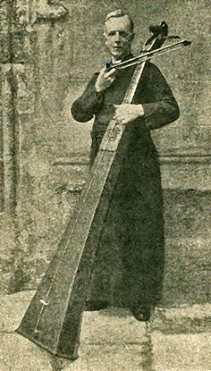](https://www.pinterest.com/pamimi/musical-instruments-of-note/)