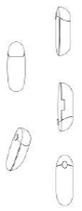

Fig. 1 Source: General Court of the European Union