The transparency of constitutional reasoning:
A text mining analysis of the Hungarian Constitutional Court’s jurisprudence

ABSTRACT
The analysis of constitutional interpretation has received much attention in recent years. With this article we contribute to this literature by using text mining methods to account for markers of constitutional reasoning in Big Data-sized text corpora. We examine how often the Hungarian Constitutional Court (HCC) reflected on the various methods of interpretation. For this purpose, we have created a complex corpus covering all HCC decisions and orders between 1990 and 2021. We found evidence that the methodological practice of the HCC is self-reflexive in general as 44% of its decisions make a reference to at least one method of interpretation. We also show that this self-reflexive nature is even more prevalent (in fact, ubiquitous) in the 100 doctrinally important decisions from the 30 years of jurisprudence in question. While this study provides a first steps towards a quantitative analysis of the reasoning of constitutional courts, further mixed methods research is needed to account for intertemporal changes in these methods and to refine the measurement of constitutional interpretation.

Keywords: Hungarian Constitutional Court, constitutional reasoning, self-reflexivity, text mining

INTRODUCTION*
In recent decades, the relevance of the judicial review has grown dramatically. It plays an increasingly important role in determining the direction, form, and content of constitutional law and policy in a growing number of countries. The methods of argumentation have become a pervasive feature of public discourse as well. The analysis of constitutional interpretation carried out in the first place by constitutional courts (and other high courts conducting judicial review) and the various methods used have received great attention in the scholarly literature. Constitutional reasoning, understood as the justification given by constitutional judges for their decisions in public is key to understanding constitutional adjudication and the legal nature of the judicial process.
This is especially true for the Hungarian Constitutional Court (HCC). Ever since the democratic transition period of 1989-1990, both the HCC and jurisprudence-related analytical legal scholarship have studied extensively the nature and attributes of the constitutional decision-making. It distinguished methods of interpretation, some of which are based strictly on the constitutional text, while others have used external sources from outside the constitutional text to determine the purpose and content of constitutional provisions. In the 1990s the focus was on dogmatic reasoning and analysis, and the Court established the standards of constitutional interpretation: a self-reflexive approach of the constitutional judiciary to legal methodology.,, The adoption of the new constitution, the Fundamental Law by Parliament in 2011 – initiated by the newly formed Orbán-government – again gave rise to several debates on constitutional interpretation in the domestic literature. Taken together, the varying levels and focal points of the methodological self-reflection of the constitutional reasoning of the HCC serves as fertile ground for an analysis of interpretative practices over a longer time frame.
In recent years, the practice of the Constitutional Court in Hungary and elsewhere has been examined qualitatively and quantitatively with different focuses and approaches. The precursors to our present analysis tend to agree that the HCC did not show a high level of explicit methodological self-reflection in its reasoning practice. In our understanding, derived from the available literature, self-reflexivity is the way the constitutional court reflects on its own interpretative activity, especially how it reflects on using one or the other method of interpretation when applying the text of the constitution. Doctrinally relevant landmark decisions (what we call the top 100 HCC decisions below) prove that it is part of the legal culture in Hungary to make explicit linguistic references to the applied method of interpretation.
In this article we suggest that if the individual judge and therefore the court itself is self-reflective on its activity, we will see the linguistic signs in the decision itself, especially in the reasoning part. Regarding this definition, it is important to note that self-reflexivity and its linguistic presence are not a strict normative requirement for a legitimate decision; however, as part of the legal culture, it is very often present in the reasoning to explain the mindset of the judge(s). Our research questions in this article, therefore, concern the extent to which such observable methods of reasoning are present in the HCC’s jurisprudence as well as the prevalence of individual methods and their dynamics.
In order to be able to conduct a quantitative analysis of a large sample of HCC decisions we collected a database which contains the decisions and orders of the HCC from 1990 to 2021. The database includes 5336 decisions and 5427 orders. We also analysed what was selected by experts to be the 100 most significant, “landmark” decisions of the HCC of this period. We investigated two hypotheses in relation to this database. Hypothesis 1 states that at least 51 per cent of all HCC decisions carry an explicit reference to at least one method of interpretation. Hypothesis 2 posits that a sample of 100 landmark decisions carry more explicit references to at least one method of interpretation per decision than the count for the full sample of decisions. The first hypothesis is rooted in extant literature and an understanding that Hungarian legal culture puts an emphasis on proper judicial reasoning in jurisprudence. The second hypothesis is based on the assumption that the Court goes out of its way to make sure this convention is upheld for what the legal community considers to be landmark decisions.
The research design applied made use of the counting of various versions of keywords that can be attributed to a number of reasoning methods which we derived from the literature. We also validated the matches extensively to make sure that only good matches were counted.
Results show that the majority of HCC decisions did not feature even a single explicit reference to one of the constitutional reasoning methods under consideration. The sample of 100 landmark decisions, however, show a decidedly higher prevalence of such markers of constitutional reasoning.
In what follows we first present a review of the relevant literature. Next, we outline our theoretical framework, formulate the research questions and the hypotheses. The following segment describes the dataset, and the quantitative empirical research methods applied. The section on results presents and interprets statistics related to the prevalence of markers of constitutional reasoning in the corpus at hand. The final section concludes and discusses avenues for future research.

LITERATURE REVIEW
In this literature review, we first consider the publications that provide a comparative analysis of the constitutional courts. Then we focus on works which examine the domestic Constitutional Court from different perspectives. The discourse on constitutional law has its own specific language. Jakab argues that the task of constitutional theory is to discover this language. In the monograph European Constitutional Language, he outlines the foundations of constitutional interpretation and statutory interpretation in European, continental law and the distinctive features of the style of reasoning of ordinary and constitutional courts and reviews the various methods of interpretation.
The principles of the constitutional interpretation in continental law are very similar to classic legal interpretation, with certain specific features, as is well described in the work by Szente and Gárdos-Orosz on the art of constitutional interpretation. Dawson and Gorla have compared the brevity and rhetorical style of French Supreme Court opinions with the more discursive approach taken by American judges. The research by Lasser and Huls also contributed to the analysis of the latter approach. By comparing the reasoning of judges in the French Cour de cassation, the US Supreme Court, and the European Court of Justice, Lasser’s analysis seeks to cast a broader light on the wider discursive context in which these judges pronounce their decisions. He explicitly points out that what he says about the reasoning practice of the Cour de cassation applies equally to the Constitutional Council (Conseil Constitutionnel).
More recent research, such as the comparative work of Goldsworthy, has begun to look specifically at how constitutional reasoning differs between constitutional systems by providing country studies. A methodological update to the research on constitutional reasoning is the study of Jakab, Dyevre, and Itzcovich in which the authors point out that studies focusing specifically on reasoning tend to be purely analytical or normative without comparative and/or empirical perspectives on constitutional and related sociological issues. In another edited volume entitled Comparative Constitutional Reasoning, the authors highlight the world's leading independently reviewed cases through a combination of qualitative and quantitative analyses (yet do not utilize text mining techniques to conduct their analyses).
Legal scholars in general, however, focus rather on how judges should arrive at their decisions in the light of what they actually do. The currently available national and international literature points to the fact that only a few studies on legal and constitutional reasoning apply quantitative methods. The analysis of legal texts by different methods has a long history, but for a long time, the field has been dominated by qualitative methods alone. The use of less traditional quantitative methods, such as text mining, has appeared in Hungary in the social sciences, similar to international trends. Since the 1990s, legal texts have increasingly been seen as data, and by using this method, previously unexplored phenomena can be made more understandable to researchers.
The text mining method is based on various data analysis algorithms to process unstructured textual data sets. Much of the information of interest to lawyers, jurists, and legal science is presented in the form of texts, whether they are pleadings, actions, contracts, court decisions, law journal articles, legislative acts, or Constitutional Court decisions. For centuries, the search for and analysis, comparison, and interpretation of these documents has been the task of legal practice and jurisprudence. Lawyers deal with words.
Dyevre explains that while the study of legal texts is as old as legal science, what is new is the emergence of a whole range of text-mining techniques for analysing and processing data, which help lawyers, researchers, and the legal community to navigate, understand, and analyse the ever-growing sea of legal and legally relevant documents. These techniques rely mainly on recent advances in machine learning and language processing technologies. In this respect, the research of Groppi and Ponthoreau, which comparatively studies the use of foreign precedents by constitutional judges, is also noteworthy. With this monograph, we now have data on the actual number of cases citing foreign case law in 16 countries. Szente contributed to the analysis of the HCC.
Where quantitative methodologies appear, they are often based on manual research on official websites and expert selections, and when based on machine learning, they typically use network research techniques. Bodnár's research encompasses various empirical methods, case law analyses, and expert interviews. The purpose of her study was to find all cases where the HCC referred to foreign law, including references to specific regulations, case law, or general concerns. The author used the public online database available on the website of the Constitutional Court for her research and applied manual counting as the website's database is unsuitable for more profound text mining research.
Following international trends, applying various text mining methods and techniques in social sciences and law has also gained ground in Hungary. One of the prominent pioneers in this field is Blutman, who examines the methodology of legal analysis. In his study, he seeks to answer the question of the rules that govern the formation, justification, or critique of legal statements, using language-centric and empirical methods to conduct a scientific analysis of legal texts. Blutman's work is pioneering since textual empiricism in the study of analytical legal dogmatics is new in current mainstream legal research and its traditions in Hungary. In his language-centred textual analyses, he assumes that individual legal norms are created through language and that only language itself can create legal norms in the human mind. In law, many questions are decided by the linguistic expression of particular ideas, which is essential in establishing the chain of causality and rationality. When studying the proportionality test, Blutman draws attention to the fact that unfortunately, the court’s language is sometimes inadequate and undefined. This appears as a difficulty in achieving conclusive results with text analysis.
Ződi's study uses network research methods to analyse and examine the interferences of the decisions of the HCC between 1990 and 2017. His research highlights that the mapped reference network follows the same pattern as almost all court reference networks around the world analysed by network research methods. The research demonstrated that network science could be an exciting complement to doctrinal jurisprudence in that network science, like other quantitative-based sciences, can reveal regularities.
Although from an investigative point of view, Pócza, Dobos, and Gyulai take a new approach to the examination of the decisions of the Hungarian Constitutional Court, as they have developed a text mining-based methodology for systematically mapping the multifaceted reality of constitutional adjudication by measuring the strength of judicial decisions. Another precursor of our present study in terms of quantitative research methodology is the volume in which Pócza and his co-authors using an innovative research methodology, quantifying the impact and effect of judicial decisions on legislation and legislators, and measuring the power of judicial decisions in six Central and Eastern European countries.
The analysis of the language of constitutional law in the HCC decisions, together with the explicit textual analysis of the legal justification of Constitutional Court decisions, have so far mostly been conducted by applying expert-based research methods. Therefore, in this study, we use a new approach – text mining. In doing so, we depart from the empirical research methods used in the past on order to support them with new findings.

Theoretical considerations and hypotheses
Studying constitutional reasoning has produced a massive literature. Based on this scholarship we understand constitutional reasoning (or argumentation which we use as a synonym of reasoning) as a special type of legal reasoning. We define interpretation as the determination of the content of normative text. Hence, interpretation is part and parcel of constitutional reasoning. As Jakab put it: “what is traditionally called ‘a method of interpretation’, is in fact a type of argument used to interpret a text.”
Law uses various methods to make its decisions, and the canon of interpretation is a common form of this. Law is first objectified in writing as a text and then processed further intellectually. Understanding or interpreting a law produces a different set of meanings; these can be fixed for a long time. For this reason, it is essential that in a democratic society, all moments of understanding and enforcing the law must be public, and therefore moments of interpretation also require some sort of publicity.
In our research, we rely on the linguistic characteristics of "justificatory reasons" in the context of reasoning, i.e., we examine the methods of reasoning that the Constitutional Court is called upon to use in the reasoning of a decision. In this study, constitutional reasoning is examined in its narrowest sense, i.e., we focus only on the text of the constitutional reasoning of constitutional courts.
The methods of interpretation themselves are generally not fixed by law but are developed by judicial practice. Where there are constitutional or statutory rules on the methods of interpretation such as in Hungary in the Fundamental Law, this is not a taxonomic list. The Hungarian domestic legislation is unique in that the constitutional legislator provides (incompletely and not exclusively) methods of interpretation in among others Article R) of the Fundamental Law.
After the democratic transition, Hungary followed the German model of constitutional jurisprudence, the methods of interpretation were developed by the Constitutional Court. In Hungary’s Article R) of the Fundamental Law, the constituent power, however, declared that “The provisions of the Fundamental Law shall be interpreted by their purposes, the National Avowal contained therein and the achievements of our historical constitution. The protection of the constitutional identity and Christian culture of Hungary shall be an obligation of every organ of the State”.
In addition to the provision of the Fundamental Law, Act CLI of 2011 on the Constitutional Court contains an explicit provision in Article 63 Subsection (2) concerning the statement of reasons for decisions which states: “With the exception of rulings with a summary statement of reasons as specified in Subsection (3) of Section 56, the Constitutional Court shall be obliged to give detailed reasoning for its decisions”. Similarly to the German model and emphasising the importance of interpretation, itis the possibility of adding concurring and dissenting opinions to the majority decision with alternative interpretation, which the Act on the Constitutional Court stats in Article 66 Subsections (2)-(3) as follows: “If a member of the Constitutional Court who opposed the decision of the Constitutional Court is outvoted, he or she shall have the right to attach his or her dissenting opinion, with a written reasoning, to the decision.” and “A member of the Constitutional Court who agrees with the merits of the decision shall have the right to attach his or her reasons in a statement if they differ from those of the majority.”
We identify different methods of interpretation in constitutional scholarship. These are very well-known reflected patterns of reasoning acknowledged as rational and legitimate, which are used to limit the scope of the interpretation of the abstract rule and avoid arbitrariness during the concretisation of the rule to the specific constitutional controversy, or to the particular constitutional question.
This doctrinal framework, which we usually call the methods of interpretation, is based on experience and is simultaneously embedded in normative philosophical requirements. Suppose the judges would like to refer to the context of the provision in the text to find out its meaning. In that case, the legal doctrine evaluates whether it is acceptable to determine the definition of a piece of an abstract text by analysing its context. In this specific case, legal scholarship has found that this judicial practice is rational and therefore qualifies as a legitimate method of interpretation, identified as the contextual method of interpretation.
Some centuries ago, the accepted methods of legal interpretation became crystallised, and constitutional law, at least as understood in the continental legal systems, adopted these methods and adapted them to the constitutional reasoning that remained in these systems – including the Hungarian – a fundamentally legal task. These methods and the legal nature of constitutional adjudication in the normative sense were crystallised after the Second World War, and doctrinal expectations regarding constitutional adjudication were formulated. These doctrinal expectations were emphasised not only by legal scholars working with a rational-legal doctrine (dogmatics according to the German usage) but also by political institutions.
The classical methods of interpretation were not named explicitly in the text of the Constitution of the democratic regime change of 1989. However, they were identified before the entering into force of the Fundamental Law by the HCC and by legal scholarship from the early nineties as the classical methods of interpretation. This paper will not provide a comprehensive and detailed description of the specific classical methods of interpretation that the Constitutional Court may use because several studies have already been written on the complexities of constitutional reasoning and the listing of correct and incorrect methods of reasoning and interpretation. For the sake of our study, measuring the self-reflexivity in the use of the methods of interpretation in constitutional court jurisprudence, we have chosen some most important methods and we aimed to prove with the above explanation that we can proceed with the text mining despite these and other differences between the two constitutional eras in Hungary before and after the entering into force of the new Fundamental Law in 2012.
In light of these considerations, below we list the methods that became important and recognisable in the jurisprudence of the HCC following the democratic transition. To take the period between 1990 and 2021 in one corpus for our examination, we will match the classical methods with the new regulations listed above from the Fundamental Law of 2011. We delineate six such methods: linguistic, teleological, contextual, historical, “beyond the law” and decision-based methods of reasoning.
First, linguistic (or grammatical) interpretation is associated with pure textualism or the so-called direct meaning rule. It is not an explicit requirement of the constitutional text of the Fundamental Law, so we will search for the related words in both the 1989 Constitution and the 2012 Fundamental Law-based jurisprudence.
Second, the teleological (purposive) interpretation wishes to discover the goal of the provision. This emerges in Article R of the Fundamental Law, in which the requirement is that constitutional provisions should be interpreted in accordance with their purposes. We would think that this provision alone would give a wide margin of appreciation to the Constitutional Court, but the next sentence in Section 4) about the protection of constitutional identity and Christian culture restricts this freedom to defining the purpose of the rule. However, we could search the words and expressions related to the teleological interpretation both in the pre2012 and the post 2012 jurisprudence.
Third, contextual interpretation occurs when the constitutional text is understood in the entire context of the constitution, considering the other related provisions of the text. The integrity of the constitutional text is a keyword in this method. Article R) of the Fundamental Law requires the broad contextual interpretation explicitly, in the strict sense, and implicitly, in the general sense. In the strict sense, it requires that the Preamble called National Avowal of the Fundamental Law be considered when interpreting the other provisions of the text. This is a requirement of the coherent interpretation of the constitutional text, which includes the preamble, i.e., the long National Avowal with the values of the political majority contained within it.
In the broad sense, we argue that when a contextual analysis is carried out on the Fundamental Law, it is not restricted to the constitution itself, according to Article R of the Fundamental Law historical constitution and Christian culture should be considered the context of the entire Fundamental Law. While we emphasize the theoretical importance of this provision, in the practice of the Constitutional Court in the examined period, this latter contextual understanding has not yet gained relevance and therefore we could use the same set of search words for both periods.
Fourth, Article R of the Hungarian Basic Law refers to the achievements of the historical constitution as a reference point for interpretation. It emphasises the long history of constitutional values in Hungary. It operates in the constitutional jurisprudence after 2012 by mentioning the achievements of the historical constitution that could be otherwise understood as a pure historical method of interpretation. Therefore, we connected the reference to the achievements of the historical constitution with the other search words related to the historical interpretation in the former and in the present constitutional jurisprudence.
Fifth, the beyond the law, or moral interpretation is based on the assumption of a political philosophy behind the constitutional text, leading the judge to a morally correct understanding of the norm. This political philosophy is based on the community’s morals in constitutional populism. The necessity of the moral sense is also present in the text of the Fundamental Law, when, for example, in Article R), the Fundamental Law requires respect for constitutional identity.
As the notion of respect for constitutional identity was not previously defined in the constitutional text or elsewhere, it did not have a legal meaning at the moment of adoption (although it did have a political one); therefore, there is — in a theoretical sense — a textual window to allow the political philosophy of the constitution-making majority to become one of the tools of interpretation. Prior to 2012, the moral interpretation was rather based on the Kantian understanding of morality that guides the decisions of constitutionality. No matter how the content is different before and after 2012, the moral interpretation as such is a legitimate, acknowledged way of classic interpretation, therefore it can be examined on the entire corpus.
Finally, we define decision-based interpretation methods as those referencing former decisions. HCC decisions do not constitute precedent in the classical (common law) sense. However, Pozsár-Szentmiklósy points out that the HCC cite its own relevant practice - in most cases citing the findings of the "reference case". This method aims to highlight the coherent practice of HCC. The literature points out that the advantage of this interpretation method is that it enhances the transparency of the structure of the reasoning of decisions and their persuasive power. This is necessary to increase public confidence in the HCC's activities.
In our research design we consider an HCC decision as self-reflexive if it includes at least one reference to any of the methods of interpretation in its reasoning. In order to understand the usage of constitutional reasoning in the jurisprudence of HCC we examine the following hypotheses:

H1: At least 51 per cent of all HCC decisions carry an explicit reference to at least one method of interpretation.
H2: The sample of 100 landmark decisions carry more explicit references to at least one method of interpretation per decision than the count for the full sample of decisions.

The first hypothesis is rooted in extant literature and an understanding that Hungarian legal culture puts an emphasis on proper judicial reasoning in jurisprudence. The second hypothesis is based on the assumption that the Court goes out of its way to make sure this convention is upheld for what the legal community considers to be landmark decisions.

Data and methods
We procured our data on the HCC’s decisions from the website of the HCC, where officially published decisions are openly available. To verify our data–as all industry-standard legal databases obtain their data from the official HCC website–we also cross-checked it using different legal databases. The database contains all of the decisions and orders of the HCC from 1990 to 2021: 5336 decisions and 5427 orders (taken together: 10763 decisions). Apart from the corpus of decisions, our database contains metadata related to each decision.
The decision texts from the initial database were pre-processed by removing all non-alpha characters (e.g., punctuation marks, numerals, roman numerals, etc.) and lowercasing them. Our analysis used two variables from the available metadata: the year of the decision and the list of citations of external legal documents. The year variable is an integer; the variables containing the cleaned texts, and citations are strings. We show the first two rows of our input data in Table 1.
Table 1: The first two rows of the input table
year | number_of_decision | cleaned_corpus | citations_to_external_documents
1990 | 1/1990. (ii. 12.) ab határozat | ab határozat a népszavazás első kérdésére adott válaszról a magyar köztársaság nevében a magyar köztársaság alkotmánybírósága az alkotmány bekezdésének értelmezése tárgyában az január ülésén egyhangú döntéssel meghozta a (…) | ['1989. évi xvii. törvény 11. paragrafus', '1989. évi xvii. törvény 5. paragrafus 1. bekezdés b. pont', '1989. évi xxxi. törvény 16. paragrafus', '1989. évi xvii. törvény 10. paragrafus 2. bekezdés a. pont', '1989. évi xvii. törvény 4. paragrafus', '1989. évi xxxv. törvény', '1989. évi xvii. törvény', '1989. évi xvii. törvény 5. paragrafus 2. bekezdés b. pont', '1989. évi xxxii. törvény 1. (...)
 | 10/1990. (iv. 27.) ab határozat | ab határozat az özvegyi nyugdíjra vonatkozó jogszabályok alkotmányellenességének megállapításáról a magyar köztársaság nevében a magyar köztársaság alkotmánybírósága tóth balázs budapesti budapest (...) | ['1975. évi ii. törvény 64/a. paragrafus', '1989. évi xxxii. törvény 1. paragrafus b. pont', '3/1975. (vi. 14.) szot szabályzat 84. paragrafus', '1989. évi xxxii. törvény 41. paragrafus', '17/1975. (vi. 14.) mt rendelet 146. paragrafus', '3/1975. (vi. 14.) szot szabályzat 87. paragrafus', '17/1975. (vi. 14.) mt rendelet', '1975. évi ii. törvény 59. paragrafus 1. bekezdés', '1975. évi ii. (...)
NOTE: The second column only contains part of the full texts for illustration purposes.
We applied a mixed methods approach to examine this corpus relying on both qualitative and quantitative methods. First, we selected the keywords related to the specific methods of interpretation based on the above academic research on constitutional and reasoning. Second, we used text mining to measure the prevalence of keywords in the underlying corpus of HCC decisions.
Our methodology relies on a dictionary-based approach. We counted the instances of keywords in every document and aggregate the number of keywords matches in the text (see Appendix A for a slew of examples related to various logics of reasoning). We examined the keyword matches in every category of methodological self-reflection. We also did a statistical Kanalysis of the total of keyword matches. Finally, we normalized the number of counts by the decisions' token lengths (i.e., word counts). In our analysis, we refer to this normalized count index as the Count Index.
The identification of search terms was conducted on several levels. The selection of words was based on the literature, so that the decisions and the keywords highlighted in previous research analysing the practice of the Constitutional Court are included in our dictionary. In addition, we have carefully analysed the expert selected 100 important decisions and highlighted the words used in them that describe methods of interpretation. Table 2 presents the six categories of reasoning and the associated keywords.
Table 2: The methods of reasoning and the associated keywords
Interpretation method | Search terms in English | Search terms in Hungarian | Terms excluded
Linguistic | Linguistic  Linguistic interpretation  Text of the Fundamental Law/Constitution  It follows from the text of the Constitution (follows)/ the Fundamental Law.  Meaning of the sentence Meaning of the provision  The Constitution does not contain a provision  From/According to the text of the Constitution  From the text and structure of the Constitution  Does not follow from the Constitution  Meaning of the text  Content of the norm  Content of the text  Content of the Constitution  Not directly following from the text  Textual meaning | Nyelvtani  Nyelvtani értelmezés  Alkotmány/Alaptörvény szövege  Alkotmány/Alaptörvény szövegéből következik (következően)  A mondat értelme  A rendelkezés értelme  Az Alkotmány nem tartalmaz rendelkezést  Alkotmány szövegének  megfelelően  Alkotmány szövegéből és szerkezetéből  Alkotmányból nem következik  Szöveg értelme  Norma tartalma  Szöveg tartalma  Alkotmánytartalom  Szövegből közvetlenül nem következő  Szövegszerinti jelentés
Teleological | Legislative purpose  Interpretation by purpose  Teleological interpretation  Purpose, function of (legal) rule(s)  Purpose of provision  Explanatory memorandum to the Bill  Constituent's intention  Purpose of the Law  It expresses the intention to  Original purpose  Original intention  The previous constitution  Tradition  Constituent purpose  Original intent | Jogalkotói cél  Cél szerinti értelmezés  Teleologikus értelmezés  (Jog)szabály(ozás)célja, rendeltetése  Rendelkezés célja  Törvény indokolása  Alkotmányozó szándéka  Törvény célja  Kifejezi azt a szándékot  Eredeti szándék  Eredeti akarat  Az előző alkotmány  Hagyomány  Alkotmányozó célja  Eredeti cél
Contextual | Taxonomic interpretation  System of the Constitution/the Fundamental Law  In the system of the Constitution/the Fundamental Law  Values of the Constitution/the Fundamental Law  Constitutional system  Reference to Preamble  Article R (3)  Legislative freedom  Constitutional framework  In accordance with the Constitution  Systematic  Logical  Constitutional development  In this context  In accordance with | Rendszertani értelmezés  Alaptörvény/Alkotmány rendszere  Az Alaptörvény/ Alkotmány rendszerében  Alkotmány/Alaptörvény értékrendje  Alkotmányos rendszer  Preambulum  R) cikk (3) bekezdése  Jogalkotói szabadság  Alkotmányos keretek  Alkotmánnyal összhangban  Rendszertani  Logikai  Alkotmányfejlődés  Ezzel összefüggésben  Ezzel összhangban | EU law
Historical | Historical  Historical constitution  Tradition  Constitutional tradition  Hungarian history  History of public law | Történeti  Történeti alkotmány  Tradíció  Alkotmányos hagyomány  Magyar történelem  Közjogtörténet | Historical facts
Beyond the law (moral) | Moral  Natural law(s)  Moral sense  Righteousness  (Constitution/Fundamental Law) conception of man(s) view(s) of humanity  National identity  Constitutional identity  Beyond the law  Extra-legal  Meta-juristic  A moral duty  Socio-economic | Morális  Természetjog(i)  Erkölcsi értelemben  Igazságosság  (Alkotmány/Alaptörvény) emberkép(e)  Nemzeti identitás  Alkotmányos identitás  Jogon túli  Jogon kívüli  Metajurisztikus  Erkölcsi kötelesség  Társadalmi-szociológiai | Scientific justice  Judicial  justice
Decision-based on former decisions | Constitutional Court (permanent) (uninterrupted) practice  Constitutional Court case law  Cases of the Constitutional Court  Constitutional precedent  Previous Constitutional Court practice  Constitutional Court in several decisions has dealt with  Constitutional Court's previous  decisions  Constitutional Court practice to date | Alkotmánybíróság (állandó) (töretlen) gyakorlata  Alkotmánybírósági joggyakorlat  Alkotmánybíróság esetjoga  Alkotmányos precedens  Állandó és következetes gyakorlat  Alkotmánybíróság határozatai  Alkotmánybíróság korábbi gyakorlata  Alkotmánybíróság számos határozatában foglalkozott  Alkotmánybíróság korábbi  döntéseiben  Alkotmánybíróság eddigi gyakorlatában
NOTE: We have made a distinction between the terms Constitution and Fundamental Law due to the entry into force of the Fundamental Law in 2012.
One marker of constitutional reasoning was referencing article R) paragraph 3 of the Basic Law. In this specific case to be as accurate as possible, we first filtered for those observations containing a reference to this paragraph based on the lists of citations. Then, we summed the instances of phrases matching this paragraph in the text. To avoid inflating our results by unwanted matches, we took two steps. First, we searched for colloquialisms, excluding keyword matches where a part of the searched expression could be part of an expression with a different meaning. Second, we excluded a stoplist of words and colloquialisms from the corpus before applying the counting.
The stoplist initially consisted of the unwanted phrases related to each methodology listed in Table 1. We then augmented the stoplist by manually filtering unwanted terms in those documents where the sum of matching keywords exceeded six. The list of augments consists of: ‘igazságok’, ‘igazságügy’, ‘igazságszolg’, ‘igazságtart’, ‘történeti hivatal’. (Due to the difficulty of accurate translations, we included the original Hungarian list.)
The list contained in Table 2 is certainly not a closed canon of methods of interpretation and even less so a definitive list of associated words and expressions. Still, the above compilation (and additional rules) are rooted in a qualitative analysis of actual decisions, Basic Law requirements and a reflection in practice that has emerged in the literature, classifying and identifying the various methods of interpretation that the HCC can use to reach its decision. A manual validation of each and every individual automatic match was also applied with non-relevant matches excluded from the final tally.
An additional methodological remark is that we make no claim that if the Constitutional Court does not name one or the other method by the words identified above it is not engaged in constitutional reasoning. We argue, however, that by using this text mining method, we could discover approximately how often and in which cases the court was explicitly self-reflective of its use of one or the other method by using those words and expressions that are widely known in legal scholarship.

Descriptive statistics
The following section includes a comparison of the select top 100 HCC decisions with the remaining 10 663 decisions out of the total of 10 763. The token length of individual decisions (i.e. the word count of pre-processed texts) ranges from 43 to 22 054; the standard deviation is slightly above 2000, and the mean is above 1700. Table 3 shows the descriptive statistics of the document lengths and the total counts. The document length distribution is uneven, with little more than 2000 tokens at the 75th percentile and a maximum of above 22 000. The total number of keyword mentions is generally low, with the 75th percentile containing one match (most decisions had no more than one keyword match).
Table 3: Descriptive statistics of the corpus
 | Document length in tokens | Keyword mentions
count | 10763 | 10763
mean | 1727 | 1.2
std | 2017.5 | 2.6
min | 43 | 0
25% | 576 | 0
50% | 1176 | 0
75% | 2011 | 1
max | 22054 | 64

We can observe a significant disparity when comparing the document lengths among the landmark 100 HCC decisions and the rest of the corpus. Table 4 compares the descriptive statistics of the two sub-groups, and Figure 1 displays the distributions of document lengths. Generally, the distribution of the top 100 HCC decisions is more skewed to the right than the rest of the corpus, ranging from 1039 to 22 013, instead of the minimum token length of 43 and maximum of 22 054 among the other decisions: landmark decisions are longer. They also contain significantly more keywords on average.

Table 4: Comparison of descriptive statistics in the two samples
 | Other HCC decisions |  | Top 100 HCC decisions
 | Document length | Keyword mentions | Document length | Keyword mentions
count | 10663 | 10663 | 100 | 100
mean | 1662.51 | 1.12 | 8608.73 | 9.79
std | 1865.64 | 2.23 | 4396.66 | 10.59
min | 43 | 0 | 1039 | 0
25% | 571 | 0 | 5367.75 | 3
50% | 1164 | 0 | 8031 | 7
75% | 1983 | 1 | 11358 | 13
max | 22054 | 36 | 22013 | 64

Figure 1: Comparison of the length of landmark decisions and rest of the corpus
Other HCC decisions
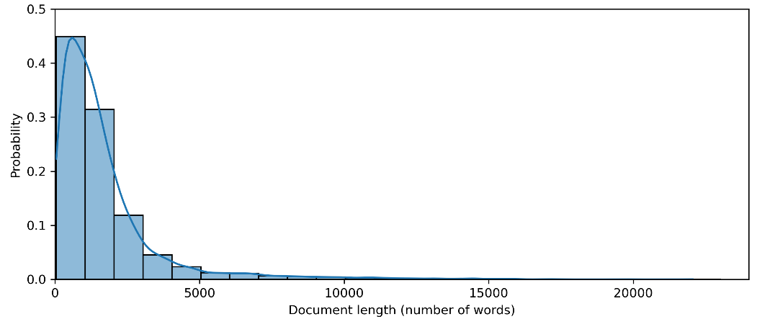
Top 100 HCC decisions
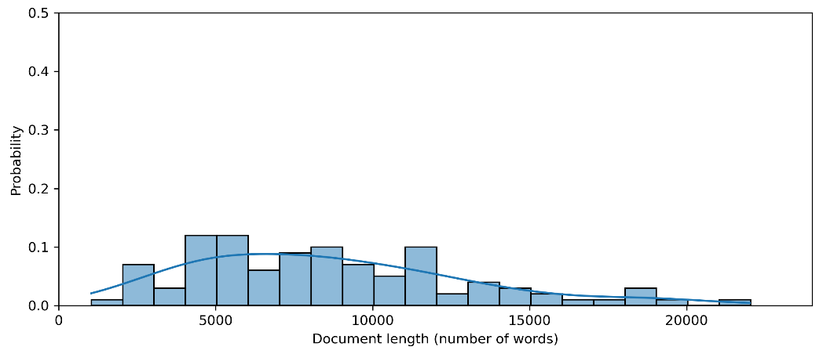
Table 5 shows a category-by-category description of our corpus. A significant difference is observable regarding the proportions of documents with at least one keyword of any category between the two groups: 99% of the expert selected, doctrinally most important decisions contained keywords, whereas this proportion is only 44% for the whole corpus of HCC jurisprudence between 1990 and 2021.
Table 5: Comparison of keywords by category
 | Top 100 HCC decisions |  |  | Other HCC decisions
 | % of total (100) | Document frequency | Keyword index | % of total (10663) |  | Document frequency | Keyword index
Linguistic | 27% | 27 | 0.01 | 4% |  | 413 | 0.37
Teleological | 48% | 48 | 0.02 | 6% |  | 633 | 0.35
Contextual | 75% | 75 | 0.03 | 21% |  | 2262 | 1.93
Historic | 48% | 48 | 0.03 | 3% |  | 294 | 0.17
Beyond the law | 26% | 26 | 0.01 | 3% |  | 325 | 0.19
Decision based on former decisions | 64% | 64 | 0.02 | 30% |  | 3169 | 2.82
 | % of documents containing keywords of total
 | Top 100 HCC decisions |  |  |  | Other HCC decisions
 |  | 99% |  |  |  | 44%

As to the referred methodology our results show that ‘decision based on former decisions’ methodology is the most prevalent in the entire corpus, with 30% of documents containing related keywords, followed by references to ‘contextual’ argumentation (21%). Also, among the top 100 decisions, references to ‘contextual’ methodology are the most frequent (75%), followed by ‘decisions based on former decisions’ (64%), then ‘teleological’ (48%) and ‘historic’ (48%) references are made the most frequently. Across all categories, the proportion of documents with at least one keyword is significantly higher among the top 100 than in the entire corpus. Figures 2 and 3 elaborate on the faceted yearly distributions of the means of count indexes, supporting the cross-sectional difference in references to constitutional reasoning shown in Table 5.

Figure 2: Yearly keyword prevalence (other HCC decisions)
Methodology: Linguistic | Methodology: Teleological | Methodology: Contextual
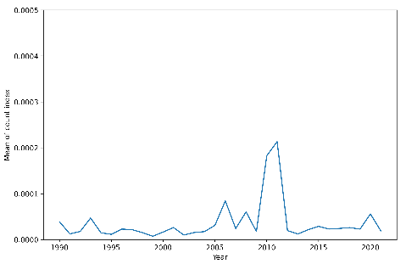 | 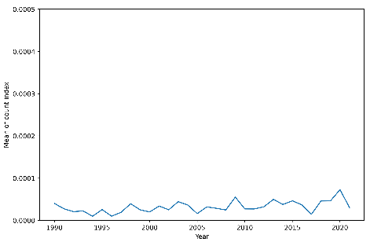 | 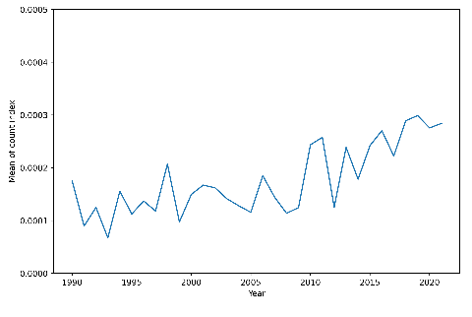
Methodology: Beyond the law | Methodology: Decision based on former decisions | Methodology: Historic
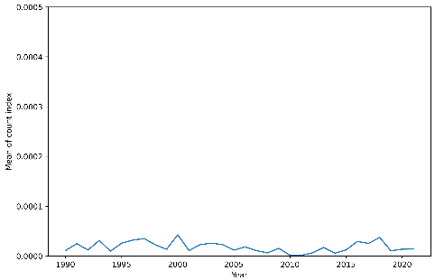 | 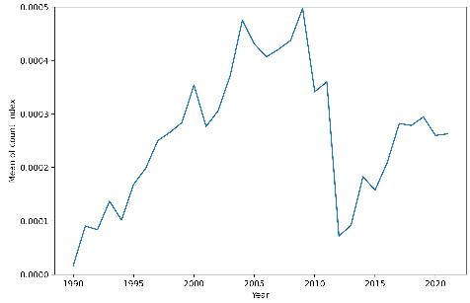 | 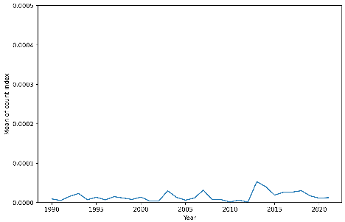

Figure 3: Yearly keyword prevalence (top 100 HCC decisions)
Methodology: Linguistic | Methodology: Teleological | Methodology: Contextual
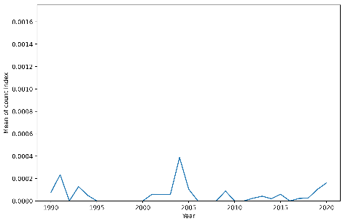 | 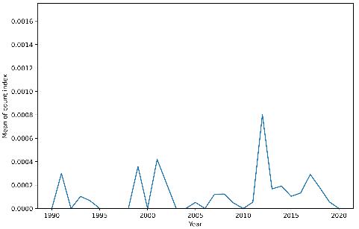 | 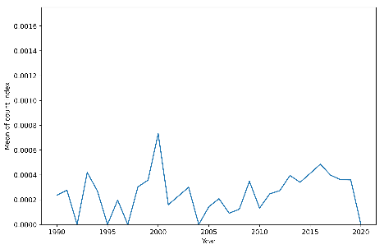
Methodology: Beyond the law | Methodology: Decision based on former decisions | Methodology: Historic
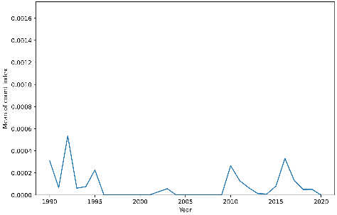 | 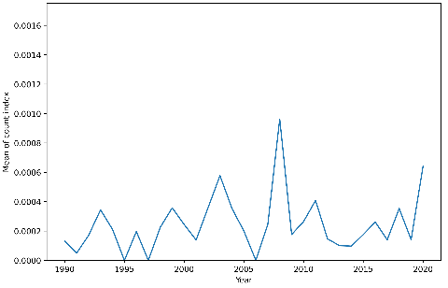 | 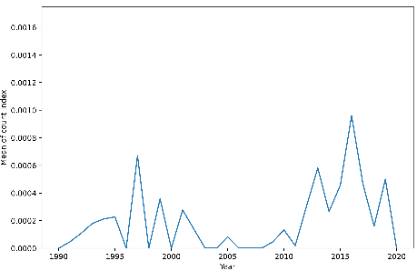

In sum, less than 50 percentage of HCC decisions contain self-reflective keywords (44%) in the complete corpus of the HCC jurisprudence. In contrast, 99% of the top 100 decisions have at least one mention of a searched term, indicative of self-reflective reasoning (see details in Table 5). The comparison of methodological references showed that mentioning the keywords ‘decision based on former decisions’ was prevalent among both groups. Still, the use of the keywords ‘contextual’, ‘teleological’ and ‘historic’ were decidedly more likely to be used in the top 100 most important landmark decisions.
Looking at the rank order of decisions with the most keywords, we see a disparity in the results, whether sorted by the total number of keyword matches or the Count Index. Tables 6 and 7 show the two top lists up to 15. We sorted Table 6 by total counts and did not apply restrictions. The top list contained ten decisions which were part of the top 100.
Table 6: Top list of decisions based on the count of keywords
Number | Decision/Order | Top 100? | Token length | Count Index | Total count
22/2019. (vii. 5.) | Decision | Yes | 18396 | 0,0035 | 64
22/2016. (xii. 5.) | Decision | Yes | 10056 | 0,0052 | 52
13/2013. (vi. 17.) | Decision | Yes | 18491 | 0,0025 | 47
2/2019. (iii. 5.) | Decision | No | 10006 | 0,0036 | 36
14/2020. (vii. 6.) | Decision | No | 22054 | 0,0015 | 34
3023/2016. (ii. 23.) | Decision | No | 9442 | 0,0034 | 32
34/2017. (xii. 11.) | Decision | Yes | 11274 | 0,0027 | 30
33/2012. (vii. 17.) | Decision | Yes | 13107 | 0,0021 | 28
1/2013. (i. 7.) | Decision | No | 19592 | 0,0014 | 27
28/2013. (x. 9.) | Decision | No | 4773 | 0,0057 | 27
32/2019. (xi. 15.) | Decision | No | 11589 | 0,0023 | 27
2/2016. (ii. 8.) | Decision | No | 9726 | 0,0028 | 27
19/2017. (vii. 18.) | Decision | No | 9831 | 0,0027 | 27
20/2014. (vii. 3.) | Decision | Yes | 22013 | 0,0012 | 26
16/2015. (vi. 5.) | Decision | No | 17015 | 0,0015 | 26

In Table 7, we only included those documents which have a length of over 3000 words, sorted by the Count Index. We did so to decrease the bias towards shorter decisions in the top list where the denominator of document length is small. Only four of the fifteen observations were part of the list of top 100 decisions. The disparity is not surprising if we consider that the distribution of document length in the top 100 is much higher than in the entire corpus.

Table 7: Top list of decisions based on the normalized count index
Number | Decision/Order | Top 100? | Token length | Count Index | Total count
28/2013. (x. 9.) | Decision | No | 4773 | 0,0057 | 27
22/2012. (v. 11.) | Decision | Yes | 3149 | 0,0054 | 17
22/2016. (xii. 5.) | Decision | Yes | 10056 | 0,0052 | 52
52/2001. (xi. 29.) | Decision | No | 4503 | 0,0042 | 19
2/2019. (iii. 5.) | Decision | No | 10006 | 0,0036 | 36
22/2019. (vii. 5.) | Decision | Yes | 18396 | 0,0035 | 64
3023/2016. (ii. 23.) | Decision | No | 9442 | 0,0034 | 32
61/2006. (xi. 15.) | Decision | No | 6840 | 0,0032 | 22
3200/2018. (vi. 21.) | Order | No | 3160 | 0,0032 | 10
3353/2012. (xii. 5.) | Decision | No | 5068 | 0,0032 | 16
3199/2018. (vi. 21.) | Order | No | 3221 | 0,0031 | 10
3334/2020. (viii. 5.) | Order | No | 3606 | 0,0031 | 11
3198/2018. (vi. 21.) | Order | No | 3296 | 0,0030 | 10
1006/b/2001. | Decision | No | 3325 | 0,0030 | 10
3164/2019. (vii. 10.) | Decision | No | 4514 | 0,0029 | 13

Results
Besides exploring our dataset in terms of its descriptive features, we also investigated two hypotheses related to the theoretical literature. Our first hypothesis set the reference threshold for the practice of the HCC to be generally considered self-reflexive as 51% of decisions containing at least one keyword. Our second hypothesis expected the sample of top 100 decisions to contain more markers related to constitutional reasoning as the rest of the corpus.
Figure 4 shows a side-by-side comparison of the distribution of the proportion of documents containing keywords in a given year. On the one hand, among the top 100 HCC decisions, every decision has at least one self-reflective keyword in most years (the sole exception is 2007). On the other hand, the same proportion is mostly below 50% among the remaining HCC decisions, despite an increasing trend since 1990 and surpassing 50% from 2015. All in all, the empirical analysis of explicit references to types of constitutional reasoning lends support to both of our hypotheses. An important caveat is the dynamics of these averages which reveal important temporal differences between various periods.

Figure 4: Proportion of decisions with keywords by year
Other HCC decisions | Top 100 HCC decisions
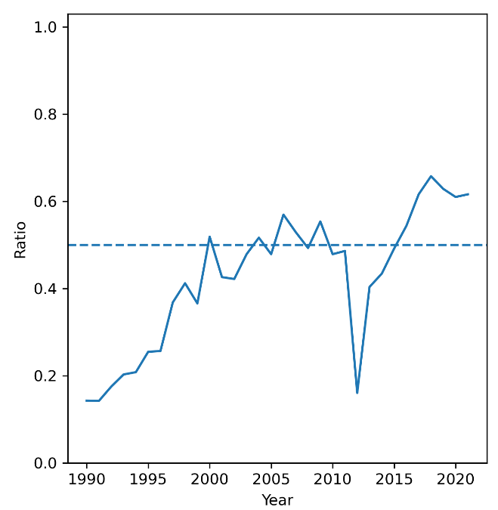 | 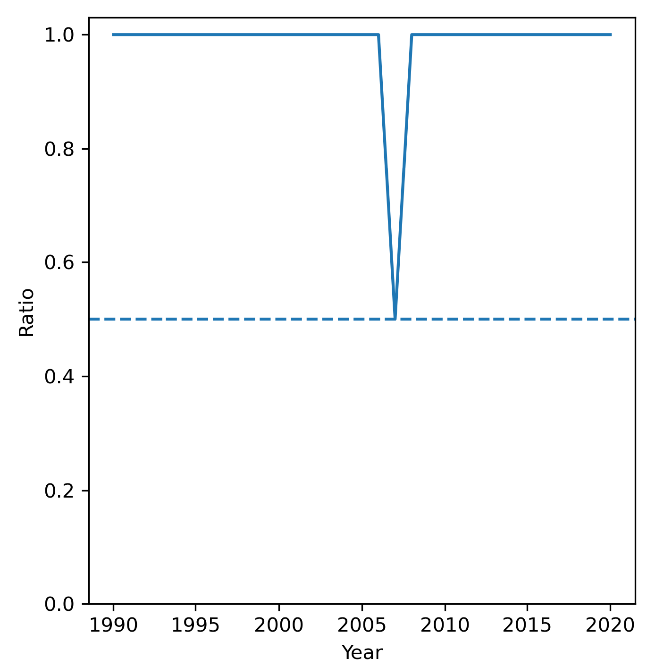
To control for the impact of the length of individual decisions we also compared the normalized distributions of the Count Indexes between the two groups (see Figure 5). A dominant spike shows the overwhelming lack of self-reflective keywords in the HCC’s argumentation in the entire corpus. However, the distribution of the top 100 decisions appears to be much flatter and skewed to the right, signalling more decisions containing more keywords regardless of length.
This cursory analysis offers a first quantitative glance on the observable markers of constitutional reasoning in the jurisprudence of the HCC over more than three decades. Further research on other country cases could reveal whether the Hungarian case is the exception or the norm in terms of the practice of explicit constitutional interpretation in decision texts. Similarly, within case comparisons (such as more systematic analysis of different periods in the composition and leadership of the court) could shed light on not just the trends in constitutional reasoning in general, but also on the limits of the research design proposed in this article.

Figure 5: Comparison of the normalized distribution of the count index
Other HCC decisions
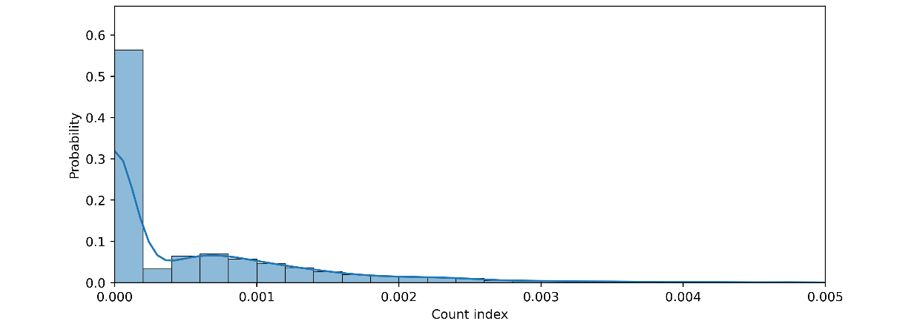
Top 100 HCC decisions
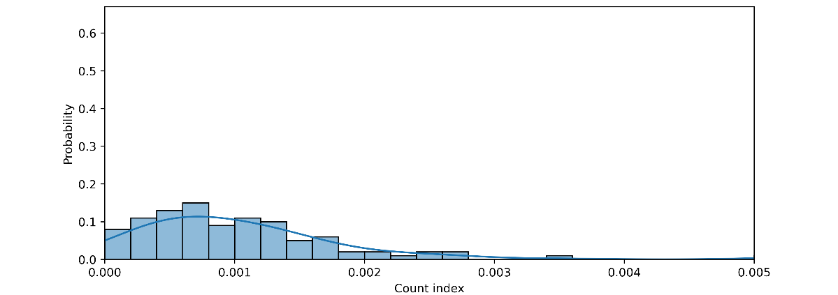
CONCLUSION
Constitutional reasoning is a critical aspect of the jurisprudence of constitutional courts. Yet despite its importance, in extant research only a few studies apply generalizable, quantitative frameworks to the study of this aspect of legal reasoning. Where quantitative methodologies are utilized, they are based on manual data collection on–mostly–subsamples of the full body of decisions based on time limitations and/or expert sampling of “important” decision.
In this article, we argued that constitutional courts use methods of interpretation to explain their decisions. It is often assumed and required that courts have a conscious and self-reflecting, visible and, therefore, transparent reasoning practice in a normative sense. As the decision process has a linguistic manifestation, the constitutional court gives a public account on its the reasoning. This often includes the reference to the methods of interpretation that were applied by the court.
In this study, we investigated which methods of constitutional reasoning and how often were referenced in the jurisprudence of the Hungarian Constitutional Court between starting from the regime change 1990 (and thus covering the democratic period where judges had real autonomy in making and discussing their decisions). In our quest to answer this research question we offered a three-fold contribution to the literature. First, we crafted a quantitative research design (rooted in a rigorous review of qualitative works) for a subject mostly analysed with a dogmatic logic that is replicable and scalable to other context for the comparative study of constitutional reasoning. Second, we applied that methodology to a new dataset of over ten thousand decisions of the HCC spanning more than three decades. Third, we offered a first, mostly descriptive statistics-based examination of the prevalence of explicit linguistic markers related to various forms of constitutional reasoning in the dataset at hand.
Our results show that practice of the HCC is not overwhelmingly self-reflexive with 44% of decisions containing at least a single reference to keywords associated with logics of constitutional interpretation. In so far as the composition is concerned, we found that the HCC often based its decisions on values and interests beyond the constitutional text by using non-legal interpretation methodology. We also examined and compared these results with the references in the expert selected top 100 landmark decisions of the HCC. Here, we found that these decisions of the HCC are more self-reflexive than the rest of the sample with almost all key decisions containing references to at least one method of interpretation. Thus, we established that the HCC makes a more concerted effort to provide explicit arguments for decisions of legal doctrinal significance.
Our methodological approach is certainly not without its limitations and can only be considered to be a first step towards a fully-fledged, mixed methods approach to account for trends in constitutional reasoning for individual courts. Here we raise two such limitations which should be explored further in future studies. A general limitation is related to the role of explicit linguistic markers in constitutional reasoning. One might claim that constitutional interpretation is subtler and can only be deciphered by “reading between the lines”. We partly confronted this argument by doing a qualitative analysis of scores of decisions as we looked for suitable keywords. We were convinced that such keywords exist but also readily accept that context matters beyond words and phrases and further efforts should be directed at understanding the linguistic representation of such reasoning better.
Secondly, and more case-oriented, our empirical results revealed major differences between individual periods in terms of the prevalence of keywords. This may reveal structural forces (such as the role of court composition) at play that should be investigated further. A corollary to this point relates to the disambiguation of token references to such reasoning and substantively applied ones. A legitimate case can be made that the higher keyword values for the post-2010 period do not betray a higher level of self-reflexion given the overall illiberal nature of the Orbán regime (and the effect of its court packing activities). Such issues can only be negotiated on a case-by-case basis and warrant the splitting of longer time frames in any research design (as we did in this article).
Despite these limitations we do not see any major obstacles to measuring and comparing the practice of other constitutional courts of states with similar legal systems, based on the methodology presented in our study. In fact, it is only with these additional studies that we can establish historically and legally relevant benchmarks for the level of constitutional self-reflexion and properly situate the results presented in this study within general trends of constitutional jurisprudence.

REFERENCES

Literature

Aaken van A. et al., Deliberation and Decision: Economics, Constitutional Theory and Deliberative Democracy, Ashgate 2004.
Aarnio, A., The Rational and the Reasonable: A Treatise on Legal Justification, Reidel 1987.
Babcock, B.A. (ed.), Signs about Signs: The Semiotics of Self-Reference. “Semiotica” 1980 vol 30.
Barak, A., Purposive Interpretation in Law, Princeton University Press 2005.
Bellamy, R., Democracy as Public Law: The Case of Rights, “German Law Journal” 2019 vol. 14(8). DOI:10.1017/S2071832200002145
Blutman L., Csatlós, E., Schiffner, I., A nemzetközi jog hatása a magyar joggyakorlatra, HVG-Orac 2014.
Blutman L., Hat tévhit a jogértelmezésben, “Jogesetek Magyarázata” 2015(3).
Blutman L., Szövegempirizmus és analitikus jogdogmatika: Jogi elemzés sub specie linguae, “Pro Futuro” 2014 vol. 4(2).
Blutman L., The Fundamental Rights Test in the Grip of Language, “Jogtudományi Közlöny” 2012(4).
Bodnár, E., The Use of Comparative Law in the Practice of the Hungarian Constitutional Court: An Empirical Analysis (1990–2019), “Hungarian Journal of Legal Studies” 2021 vol. 61(1). DOI: 10.1556/2052.2020.00306
Brodocz A., Constitutional Courts and Their Power of Interpretation, [in:] Law, Politics, and the Constitution. New Perspectives from Legal and Political Theory, ed. Geisler, A., Hein, M., Hummel, S., Peter Lang 2014.
Dawson, J. P., The Oracles of the Law, University of Michigan Law School 1968.
Drinóczi T., Bień-Kacała, A., Illiberal Constitutionalism: The Case of Hungary and Poland “German Law Journal” 2019 vol. 20(8). DOI: 10.1017/glj.2019.83
Dyevre, A., Jakab A., Foreword: Understanding Constitutional Reasoning, “German Law Journal” 2013 vol. 14(8). DOI: 10.1017/S2071832200002133
Dyevre, A., Text-Mining for Lawyers: How Machine Learning Techniques Can Advance Our Understanding of Legal Discourse, “Erasmus Law Review” 2021(14), <https://papers.ssrn.com/sol3/papers.cfm?abstract_id=3734430>.
Fallon, R. H., The Core of an Uneasy Case for Judicial Review, “Harvard Law Review” 2007(121).
Forsthoff, E., Die Umbildung des Verfassungsgesetzes, [in:] Festschrift für Carl Schmitt zum 70. Geburtstag, eds. Barion, H., Forsthoff, E., Weber, W., Duncker, Humblot 1959.
Fröhlich J., Az Alkotmánybíróság és a Kúria alkotmányértelmezése: Az Alaptörvény R) és 28. cikkei [in:] Az Alaptörvény érvényesülése a bírói gyakorlatban III. Alkotmányjogi panasz: az alapjog-érvényesítés gyakorlata, Balogh É., HVG-ORAC 2019.
Fuller, L.L., Winston, K.I., The Forms and Limits of Adjudication, “Harvard Law Review” 1978(92).
Gárdos-Orosz F., Constitutional Interpretation under the New Fundamental Law of Hungary [in:] Populist Challenges to Constitutional Interpretation in Europe and Beyond, eds. Gárdos-Orosz F., Szente Z., Routledge 2021.
Gárdos-Orosz F., Szente Z. (eds.), Populist Challenges to Constitutional Interpretation in Europe and Beyond, Routledge 2021.
Gárdos-Orosz F., Szente Z., The Art of Constitutional Interpretation, [in:] Populist Challenges to Constitutional Interpretation in Europe and Beyond, eds. Gárdos-Orosz F., Szente Z., Routledge 2021.
Gárdos-Orosz F., Zakariás K. (eds.), Az Alkotmánybírósági Gyakorlat I-II. Az Alkotmánybíróság 100 elvi jelentőségű határozata 1990–2020, HVG Orac 2021.
Gárdos-Orosz F., Zakariás K. (eds.), Thirty Most Important Decisions From the 30 Years of the Hungarian Constitutional Court, Nomos 2022.
Goldsworthy, J., Constitutional Interpretation, [in:] The Oxford Handbook of Comparative Constitutional Law, eds. Rosenfeld, M., Sajó, A., Oxford University Press 2012.
Goldsworthy, J., Interpreting Constitutions: A Comparative Study, Oxford University Press 2006.
Gorla, G., Lo stile delle sentenze, ricerca storico-comparativa e testi commentate, Foro Italiano 1968.
Griffin, S.M., American Constitutionalism: From Theory to Politics, Princeton University Press 1996.
Groppi, T. , Ponthoreau, M. (eds.), The Use of Foreign Precedents by Constitutional Judges, Hart Publishing 2013.
Guastini, R., L’interpretazione die documenti normative, Guiffrè 2004.
Habermas, J., Faktizität und Geltung. Beiträge zur Diskurstheorie des Rechts und des demokratischen Rechtsstaats, Suhrkamp 1992.
Halmai G., The Hungarian Approach to Constitutional Review: The End of Activism? The First Decade of the Hungarian Constitutional Court, [in:] Constitutional Justice, East and West, ed. Sadurski, W., The Hague: Kluwer Law International 2002.
Houlgate, S., Hegel’s Aesthetics, “The Stanford Encyclopedia of Philosophy” Winter 2021 Edition, <https://plato.stanford.edu/archives/win2021/entries/hegel-aesthetics/>
Huls, N. et al. (eds.), The Legitimacy of Highest Courts’ Rulings – Judicial Deliberations and Beyond, Springer 2009.
Itzcovich, G., On the Legal Enforcement of Values. The Importance of the Institutional Context, [in:] The Enforcement of EU Law and Values: Ensuring Member States Compliance, eds. Jakab A., Kochenov, D., Oxford University Press 2017.
J. Goldsworthy (ed.) Interpreting Constitutions. A Comparative Study, Oxford University Press 2007.
Jackson, V.C., Multi-Valenced Constitutional Interpretation and Constitutional Comparisons: An Essay in Honor of Mark Tushnet, “Quinnipiac Law Review” 2008(26).
Jakab A. et al. (eds.), Comparative Constitutional Reasoning, Cambridge University Press 2017.
Jakab A. et al., Conreason–the Comparative Constitutional Reasoning Project. Methodological Dilemmas and Project Design MTA Law Working Papers 2015(9).
Jakab A., Az alkotmányértelmezés módszerei, “Századvég” 2018 vol. 1.
Jakab A., Az európai alkotmányjog nyelve, Nemzeti Közszolgálati Egyetem 2016,
Jakab A., Fröhlich J., The Constitutional Court of Hungary, [in:] Comparative Constitutional Reasoning, A. eds. Jakab et al., Cambridge University Press 2017.
Jakab A., Judicial Reasoning in Constitutional Courts: A European Perspective, “German Law Journal” 2013 vol. 14(8). DOI: 10.1017/S207183220000225X
Jakab A., Kazai V.Z., A Sólyom-bíróság hatása a magyar alkotmányjogi gondolkodásra, [in:] Kontextus által világosan: a Sólyom-bíróság antiformalista elemzése eds. T. Győrfi, V.Z. Kazai, E. Orbán, L'Harmattan Kiadó 2022.
Jestaedt, M. et al., The German Federal Constitutional Court: The Court Without Limits, Oxford University Press 2020.
Kischel, U., Die Begründung, Mohr Siebeck 2003.
Kovács K., Tóth G.A., Hungary's Constitutional Transformation, “European Constitutional Law Review” 2011 vol. 7. DOI: 10.1017/S1574019611200038
Lasser, M. de S., Judicial Deliberations: A Comparative Analysis of Judicial Transparency and Legitimacy, Oxford University Press 2004.
Pócza K., (ed.) Constitutional politics and the judiciary: Decision-making in Central and Eastern Europe, Routledge 2018.
Pócza K., Dobos G., Gyulai A., How to Measure the Strength of Judicial Decisions: A Methodological Framework, “German Law Journal” 2017 vol. 18(6). DOI: 10.1017/S2071832200022422
Pokol B., Constitutionalization and Political Fighting through Litigation, “Jogelméleti Szemle” 2002 vol 1.
Pozsár Szentmiklósy Z., Precedents and case-based reasoning in the case law of the Hungarian Constitutional Court [in:] Constitutional Law and Precedent International Perspectives on Case-Based Reasoning, ed. Florczak-Wątor, M., Routledge 2022.
Samaha, A.M., Low Stakes and Constitutional Interpretation, “University of Chicago Public Law & Legal Theory Working Paper” 2010, vol. 13.
Scharpf, F. W., Grenzen der richterlichen Verantwortung. Die political-question Doktrin in der Rechtsprechung des amerikanischen Supreme Court, C.F. Müller 1965.
Smith, J., Self-Consciousness, “The Stanford Encyclopedia of Philosophy” Summer 2020 Edition, <https://plato.stanford.edu/entries/self-consciousness/
Sólyom L., Introduction to the Decisions of the Constitutional Court of the Republic of Hungary, [in:] Constitutional Judiciary in a New Democracy. The Hungarian Constitutional Court, eds. L. Sólyom, G. Brunner, University of Michigan Press 2000.
Sólyom L., The Rise and Decline of Constitutional Culture in Hungary, [in:] Constitutional Crisis in the European Constitutional Area, eds. Bogdandy von A., Sonnevend P., Hart Publishing 2015.
Stawecki, T., Autonomous constitutional interpretation, International “Journal for the Semiotics of Law” 2012(25). DOI: 10.1007/s11196-011-9243-8
Szente Z. (ed.), Hungary: Unsystematic and Incoherent Borrowing of Law. The Use of Foreign Judicial Precedents in the Jurisprudence of the Constitutional Court, 1999–2010, [in:] The Use of Foreign Precedents by Constitutional Judges, eds. T. Groppi, M.C. Ponthoreau, Hart Publishing 2013.
Szente Z., The Interpretive Practice of the Hungarian Constitutional Court: A Critical View, “German Law Journal” 2013 vol. 14(8). DOI: 10.1017/S2071832200002418
Takács A., A jogértelmezés alapjai és korlátai, “Jogtudományi Közlöny” 1993 vol. 48(3).
Tóth G.A., Historicism or Art Nouveau in Constitutional Interpretation? A Comment on Zoltán Szente's The Interpretive Practice of the Hungarian Constitutional Court – a Critical View, “German Law Journal” 2013 vol. 14(8). DOI: 10.1017/S207183220000242X
Tóth J. Z., Constitutional Reasoning and Constitutional Interpretation: Analysis on Certain Central European Countries, Ferenc Mádl Institute of Comparative Law 2021.
Tóth J. Z., Excerpts from the Development of Methods of Legal Interpretation, “Law, Identity and Values”, 2022 vol. 2(1). DOI: 10.55073/2022.1.241-264
Varga Cs., Jogváltozás a jogban és a jogi folyamatokban, “MTA Law Working Papers” 2020(33).
Waldron, J., The Core of the Case Against Judicial Review, “Yale Law Journal” 2005 vol. 115(6).
Wróblewski, J., An outline of a general theory of legal interpretation and constitutional interpretation “Acta Universitatis Lodziensis. Folia Iuridica” 1987 vol. 32.
Zakariás K., A bírói döntések alkotmánybírósági felülvizsgálata terjedelmének dogmatikai keretei – A jogalkalmazás közvetlen és közvetett alapjogsértésének kontrollja a német és magyar gyakorlat tükrében, “Állam- és Jogtudomány” 2021(62).
Zifcak, S., Hungary’s Remarkable, Radical Constitutional Court, “Journal of Constitutional Law in Eastern and Central Europe” 1996 vol 3.
Ződi Zs., Az Alkotmánybírósági Ítéletek Hálózatának Elemzése, “MTA Law Working Papers” 2020(22).
Ződi Zs., Lőrincz V., Az Alaptörvény és az alkotmánybírósági gyakorlat megjelenése a rendes bíróságok gyakorlatában, 2012–2016 [in:] Normativitás és empíria: A rendes bíróságok és az alkotmánybíróság kapcsolata az alapjog-érvényesítésben, 2012–2016, ed. Gárdos-Orosz F., Társadalomtudományi Kutatóközpont, Jogtudományi Intézet 2019.

* The underlying data, codes and other materials are available at the website of the Open Science Framework (OSF): https://osf.io/ftqz4/?view_only=aec26b874abd455a86b3877be20ac750 (Last Updated: 10-19-2022). For valuable comments on earlier drafts of this article, the authors thank András Jakab, Zoltán Szente, Zsolt Ződi, Kinga Zakariás, Nóra Chronowski, Mátyás Bencze and Evelin Burján. We would also like to thank Zoltán Kacsuk, Bálin György Kubik and Viktor Kovács for their suggestions regarding the database.
A. Jakab et al. (eds.), Comparative Constitutional Reasoning, Cambridge University Press 2017.
See, for example, A. Barak, Purposive Interpretation in Law, Princeton University Press 2005; J. Goldsworthy (ed.) Interpreting Constitutions. A Comparative Study, Oxford University Press 2007; A.M. Samaha, Low Stakes and Constitutional Interpretation, “University of Chicago Public Law & Legal Theory Working Paper” 2010, vol. 13.
See, for example, A. Aarnio, The Rational and the Reasonable: A Treatise on Legal Justification, Reidel 1987; J. Habermas, Faktizität und Geltung. Beiträge zur Diskurstheorie des Rechts und des demokratischen Rechtsstaats, Suhrkamp 1992; U. Kischel, Die Begründung, Mohr Siebeck 2003; and A. Brodocz, Constitutional Courts and Their Power of Interpretation, [in:] Law, Politics, and the Constitution. New Perspectives from Legal and Political Theory, ed. A. Geisler, M. Hein, S. Hummel, Peter Lang 2014 pp. 15–29.
G. Halmai, The Hungarian Approach to Constitutional Review: The End of Activism? The First Decade of the Hungarian Constitutional Court, [in:] Constitutional Justice, East and West, ed. W. Sadurski, The Hague: Kluwer Law International 2002, pp. 189-211.; Z. Szente, The Interpretive Practice of the Hungarian Constitutional Court: A Critical View, “German Law Journal” 2013 vol. 14(8), pp. 1591–1614.; G.A. Tóth, Historicism or Art Nouveau in Constitutional Interpretation? A Comment on Zoltán Szente's The Interpretive Practice of the Hungarian Constitutional Court – a Critical View, “German Law Journal” 2013 vol. 14, pp. 1615–1626.; T. Drinóczi, A. Bień-Kacała, Illiberal Constitutionalism: The Case of Hungary and Poland “German Law Journal” 2019 vol. 20(8), pp. 1140–1166. and F. Gárdos-Orosz, Z. Szente (eds.), Populist Challenges to Constitutional Interpretation in Europe and Beyond, Routledge 2021.
It is generally considered that the HCC was "activist" in its practice, both in its powers and in its interpretation, during the period of László Sólyom's presidency. See B. Pokol, Constitutionalization and Political Fighting through Litigation, “Jogelméleti Szemle” 2002 vol 1., S. Zifcak, Hungary’s Remarkable, Radical Constitutional Court, “Journal of Constitutional Law in Eastern and Central Europe” 1996 vol 3. This means that the HCC interpreted several abstract constitutional provisions as conferring jurisdiction on itself and went beyond the statutory rules in certain areas of its jurisdiction. Interpretative activism can be understood as a frequent departure from the constitutional text. The HCC was also criticised for creating new rules by an interpretation that was not present in the text or by not developing well-founded reasonings for one or other decisions.
A. Jakab, V.Z. Kazai, A Sólyom-bíróság hatása a magyar alkotmányjogi gondolkodásra, [in:] Kontextus által világosan: a Sólyom-bíróság antiformalista elemzése eds. T. Győrfi, V.Z. Kazai, E. Orbán, L'Harmattan Kiadó 2022, pp. 115-137.; K. Kovács, G.A. Tóth, Hungary's Constitutional Transformation, “European Constitutional Law Review” 2011 vol. 7, pp. 183–203.
L. Sólyom, Introduction to the Decisions of the Constitutional Court of the Republic of Hungary, [in:] Constitutional Judiciary in a New Democracy. The Hungarian Constitutional Court, eds. L. Sólyom, G. Brunner, University of Michigan Press 2000.
A. van Aaken et al., Deliberation and Decision: Economics, Constitutional Theory and Deliberative Democracy, Ashgate 2004.; L. Sólyom, The Rise and Decline of Constitutional Culture in Hungary, [in:] Constitutional Crisis in the European Constitutional Area, eds. A. von Bogdandy, P. Sonnevend, Hart Publishing 2015.
In this respect it does not matter if the decision is based on the Act XX of 1949 of the Constitution or on the Fundamental Law of Hungary after 2012.
A. Jakab, J. Fröhlich, The Constitutional Court of Hungary, [in:] Comparative Constitutional Reasoning, A. eds. Jakab et al., Cambridge University Press 2017.; Z. Szente (ed.), Hungary: Unsystematic and Incoherent Borrowing of Law. The Use of Foreign Judicial Precedents in the Jurisprudence of the Constitutional Court, 1999–2010, [in:] The Use of Foreign Precedents by Constitutional Judges, eds. T. Groppi, M.C. Ponthoreau, Hart Publishing 2013; F. W. Scharpf, Grenzen der richterlichen Verantwortung. Die political-question Doktrin in der Rechtsprechung des amerikanischen Supreme Court, C.F. Müller 1965.
To understand self-consciousness and self-reflection, we draw on philosophy and psychology as a starting point. In the most general sense, the terms reflexive, reflexivity, and reflexiveness “describe the capacity of language and of thought – of any system of signification – to turn or bend back upon itself, to become an object to itself, and to refer to itself”. See B. A. Babcock (ed.), Signs about Signs: The Semiotics of Self-Reference. “Semiotica” 1980 vol 30. p. 4. According to philosophy, the meaning of the term self-consciousness is that “Self-consciousness can be understood as an awareness of oneself.” See J. Smith, Self-Consciousness, “The Stanford Encyclopedia of Philosophy” Summer 2020 Edition, <https://plato.stanford.edu/entries/self-consciousness/>. visited: 30 July 2022. Hegel declared that self-reflexivity is one of the basic principles of philosophy; it is what primarily determines rational thinking: “Life itself becomes more explicitly rational and self-determining when it becomes conscious and self-conscious”. See S. Houlgate, Hegel’s Aesthetics, “The Stanford Encyclopedia of Philosophy” Winter 2021 Edition, <https://plato.stanford.edu/archives/win2021/entries/hegel-aesthetics/> visited: 30 July 2022.
See F. Gárdos-Orosz, K. Zakariás (eds.), Az Alkotmánybírósági Gyakorlat I-II. Az Alkotmánybíróság 100 elvi jelentőségű határozata 1990–2020, HVG Orac 2021.
F. Gárdos-Orosz, K. Zakariás (eds.), Thirty Most Important Decisions From the 30 Years of the Hungarian Constitutional Court, Nomos 2022, p. 7. The editors narrowed this selection down to 30 decisions of international interest, selected to explain the main lines and the main turns and shifts in the jurisprudence, and the different legal character of the jurisprudence at different points in time.
A. Jakab, Az alkotmányértelmezés módszerei, “Századvég” 2018 vol. 1, p. 30; A. Jakab, Az európai alkotmányjog nyelve, Nemzeti Közszolgálati Egyetem 2016, pp. 34–35.; A. Takács, A jogértelmezés alapjai és korlátai, “Jogtudományi Közlöny” 1993 vol. 48(3), pp. 121-122.
A. Jakab, European Constitutional Language, Cambridge University Press 2016.
See R. Guastini, L’interpretazione die documenti normative, Guiffrè 2004, pp. 277–278; E. Forsthoff, Die Umbildung des Verfassungsgesetzes, [in:] Festschrift für Carl Schmitt zum 70. Geburtstag, eds. H. Barion, E. Forsthoff, W. Weber, Duncker & Humblot 1959, pp. 35–62. Cited by: A. Jakab, European Constitutional Language, Cambridge University Press 2016, p. 21.; T. Stawecki, Autonomous constitutional interpretation, International “Journal for the Semiotics of Law” 2012(25), pp. 505–535.; J. Wróblewski, An outline of a general theory of legal interpretation and constitutional interpretation “Acta Universitatis Lodziensis. Folia Iuridica” 1987 vol. 32. p. 34.
F. Gárdos-Orosz, Z. Szente, The Art of Constitutional Interpretation, [in:] Populist Challenges to Constitutional Interpretation in Europe and Beyond, eds. F. Gárdos-Orosz, Z. Szente, Routledge 2021.
J. P. Dawson, The Oracles of the Law, University of Michigan Law School 1968.
G. Gorla, Lo stile delle sentenze, ricerca storico-comparativa e testi commentate, Foro Italiano 1968.
M. de S. Lasser, Judicial Deliberations: A Comparative Analysis of Judicial Transparency and Legitimacy, Oxford University Press 2004.
N. Huls et al. (eds.), The Legitimacy of Highest Courts’ Rulings – Judicial Deliberations and Beyond, Springer 2009.
J. Goldsworthy, Interpreting Constitutions: A Comparative Study, Oxford University Press 2006.
A. Jakab et al., Conreason–the Comparative Constitutional Reasoning Project. Methodological Dilemmas and Project Design MTA Law Working Papers 2015(9) pp. 3–23.
See, for example, V.C. Jackson, Multi-Valenced Constitutional Interpretation and Constitutional Comparisons: An Essay in Honor of Mark Tushnet, “Quinnipiac Law Review” 2008(26) pp. 599–670.; G. Itzcovich, On the Legal Enforcement of Values. The Importance of the Institutional Context, [in:] The Enforcement of EU Law and Values: Ensuring Member States Compliance, eds. A. Jakab, D. Kochenov, Oxford University Press 2017 pp. 28–43.; S.M. Griffin, American Constitutionalism: From Theory to Politics, Princeton University Press 1996 pp. 140-191.
A. Dyevre, Text-Mining for Lawyers: How Machine Learning Techniques Can Advance Our Understanding of Legal Discourse, “Erasmus Law Review” 2021(14), <https://papers.ssrn.com/sol3/papers.cfm?abstract_id=3734430>. visited: 30 November 2022.
T. Groppi, M. Ponthoreau (eds.), The Use of Foreign Precedents by Constitutional Judges, Hart Publishing 2013.
F. Gárdos-Orosz, Z. Szente (eds.), Populist Challenges to Constitutional Interpretation in Europe and Beyond, Routledge 2021.
E. Bodnár, The Use of Comparative Law in the Practice of the Hungarian Constitutional Court: An Empirical Analysis (1990–2019), “Hungarian Journal of Legal Studies” 2021 vol. 61(1).
L. Blutman, Szövegempirizmus és analitikus jogdogmatika: Jogi elemzés sub specie linguae, “Pro Futuro” 2014 vol. 4(2), pp. 105–125.
See also L. Blutman, E. Csatlós, I. Schiffner, A nemzetközi jog hatása a magyar joggyakorlatra, HVG-Orac 2014.
L. Blutman, The Fundamental Rights Test in the Grip of Language, “Jogtudományi Közlöny” 2012(4), pp. 145–156.
For theoretical approaches, see L. Blutman, Hat tévhit a jogértelmezésben, “Jogesetek Magyarázata” 2015(3), pp. 91–92.
Zs. Ződi, Az Alkotmánybírósági Ítéletek Hálózatának Elemzése, “MTA Law Working Papers” 2020(22).; Zs. Ződi, V. Lőrincz, Az Alaptörvény és az alkotmánybírósági gyakorlat megjelenése a rendes bíróságok gyakorlatában, 2012–2016 [in:] Normativitás és empíria: A rendes bíróságok és az alkotmánybíróság kapcsolata az alapjog-érvényesítésben, 2012–2016, ed. F. Gárdos-Orosz, Társadalomtudományi Kutatóközpont Jogtudományi Intézet 2019.
K. Pócza, G. Dobos, A. Gyulai, How to Measure the Strength of Judicial Decisions: A Methodological Framework, “German Law Journal” 2017 vol. 18(6)
K. Pócza (ed.) Constitutional politics and the judiciary: Decision-making in Central and Eastern Europe, Routledge 2018.
A. Jakab, Judicial Reasoning in Constitutional Courts: A European Perspective, “German Law Journal” 2013 vol. 14(8) p. 1216.; Z. Tóth J. Constitutional Reasoning and Constitutional Interpretation: Analysis on Certain Central European Countries, Ferenc Mádl Institute of Comparative Law 2021, p. 17.
A. Jakab, European Constitutional Language, Cambridge University Press 2016, p 18.
M. Jestaedt, et al., The German Federal Constitutional Court: The Court Without Limits, Oxford University Press 2020, p. 70.
Cs. Varga, Jogváltozás a jogban és a jogi folyamatokban, “MTA Law Working Papers” 2020(33) pp. 1–47.
A. Dyevre, A. Jakab, Foreword: Understanding Constitutional Reasoning, “German Law Journal” 2013 vol. 14(8) pp. 983–1015.
For a broader approach to the concept, see R. Bellamy, Democracy as Public Law: The Case of Rights, “German Law Journal” 2019 vol. 14(8) p. 1017.; and J. Waldron, The Core of the Case Against Judicial Review, “Yale Law Journal” 2005 vol. 115(6) p. 1346.; R. H. Fallon, The Core of an Uneasy Case for Judicial Review, “Harvard Law Review” 2007(121) p. 1693.
J. Fröhlich, Az Alkotmánybíróság és a Kúria alkotmányértelmezése: Az Alaptörvény R) és 28. cikkei [in:] Az Alaptörvény érvényesülése a bírói gyakorlatban III. Alkotmányjogi panasz: az alapjog-érvényesítés gyakorlata, É. Balogh, HVG-ORAC 2019, p. 374.; K. Zakariás, A bírói döntések alkotmánybírósági felülvizsgálata terjedelmének dogmatikai keretei – A jogalkalmazás közvetlen és közvetett alapjogsértésének kontrollja a német és magyar gyakorlat tükrében, “Állam- és Jogtudomány” 2021(62) p. 106.
In case of the rejection of admission, the panel shall pass an order that contains a short reasoning specifying the ground for rejection.
J. Goldsworthy, Constitutional Interpretation, [in:] The Oxford Handbook of Comparative Constitutional Law, eds. M. Rosenfeld, A. Sajó, Oxford University Press 2012.
L.L. Fuller, K. I. Winston, The Forms and Limits of Adjudication, “Harvard Law Review” 1978(92) p. 354.
Noteworthy is the German practice, where the Rules of Procedure of the Federal Constitutional Court require that, as a general rule, a written opinion (Votum) must be submitted in all Council (Senat) cases and only exceptionally, in simpler cases, a reasoned draft decision may be submitted (§ 23). This opinion is in effect a technical report, which summarises everything needed to decide the case and sets out the investigation step by step. This material can run to hundreds of pages for complex cases. See Rules of Procedure of the Federal Constitutional Court <http://www.gesetze-im-internet.de/englisch_bverfggo/index.html>.
F. Gárdos-Orosz, Z. Szente, The Art of Constitutional Interpretation, [in:] Populist Challenges to Constitutional Interpretation in Europe and Beyond, eds. F. Gárdos-Orosz, Z. Szente, Routledge 2021.
F. Gárdos-Orosz, Constitutional Interpretation under the New Fundamental Law of Hungary [in:] Populist Challenges to Constitutional Interpretation in Europe and Beyond, eds. F. Gárdos-Orosz, Z. Szente, Routledge 2021. An additional pragmatic interpretation occurs when the judge considers the decision's social, economic, technological, political, etc., effects. Article N) of the Fundamental Law requires all state organs to act with respect to the financial goals of the state. However, this provision does not have significant relevance, as according to Article 37 Section 4), the Constitutional Court cannot review controversies related to public finance legislation. Still, if the Constitutional Court must observe the financial goals of the state, the necessity of the pragmatic approach to the constitutional interpretation becomes a requirement. Search words related to this interpretation is therefore valid both before and after 2012.
Z. Pozsár Szentmiklósy, Precedents and case-based reasoning in the case law of the Hungarian Constitutional Court [in:] Constitutional Law and Precedent International Perspectives on Case-Based Reasoning, ed. M. Florczak-Wątor, Routledge 2022, p. 116–117.
A. Jakab et al. (eds.), Comparative Constitutional Reasoning, Cambridge University Press 2017.; F. Gárdos-Orosz, K. Zakariás (eds.), Az Alkotmánybírósági Gyakorlat I-II. Az Alkotmánybíróság 100 elvi jelentőségű határozata 1990–2020, HVG Orac 2021.; Z. Tóth J., Excerpts from the Development of Methods of Legal Interpretation, “Law, Identity and Values”, 2022 vol. 2(1), p. 241–264.
In addition, the decision referred to in our study as the "top 100" decision has been re-read and the terms used to refer to the interpretative methods used in it have been collected.
The Hungarian version refers to the memorandum of the „law”, as this is what is used in practice. Yet in reality the memorandum is associated with the bills.

